Marvin Lee Sprunger
January 28, 1927 – June 30, 1998

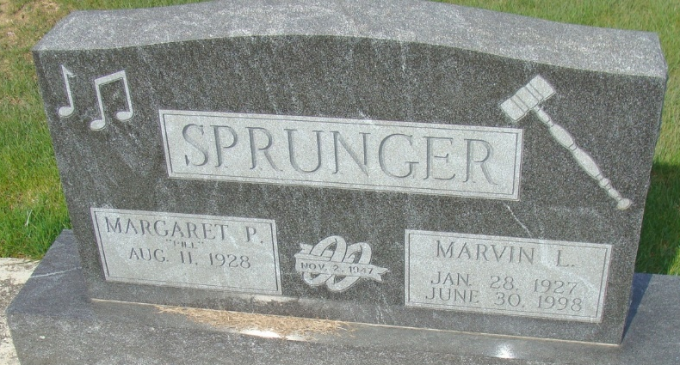
Photo by Alicia Kneuss
Marvin L. Sprunger, 71, of Berne, an auctioneer and Realtor, died at Lutheran Hospital on Tuesday, June 30. The Adams County native had worked at Central Soya, Sprunger Implement and Rea Magnet Wire in addition to McIntosh-Berne, from which he retired after 26 years' work. He also worked with his brother in his firm, Ed Sprunger Real Estate, for 25 years. He was a member of Bethel Brethren Church in Berne, the Indiana Auctioneers Association and Indiana Realtors. He also was involved with the Reppert School of Auctioneering.
Surviving are his wife, Margaret P.; sons, Duane M. and Randy L., both of Berne; a daughter, Nancy J. Van Emon of Berne; a brother, Ed F., of Decatur; and four grandchildren. Another brother, Robert F., preceded him in death, as did two of his grandchildren.
Services are 2:30 p.m. Friday at the church, where calling is 6 to 8 p.m. today and 2 to 4 and 6 to 8 p.m. Thursday. Burial will be in M.R.E. Cemetery. Memorials are to the church or Grace College Music Department. Information provided by Haggard and Sefton Funeral Home, Decatur, 1-219-724-7167.

News-Sentinel, The (Allen County, Indiana)
Wednesday, July 1, 1998

