Marvin D. Sprunger
October 11, 1923 – August 20, 1985

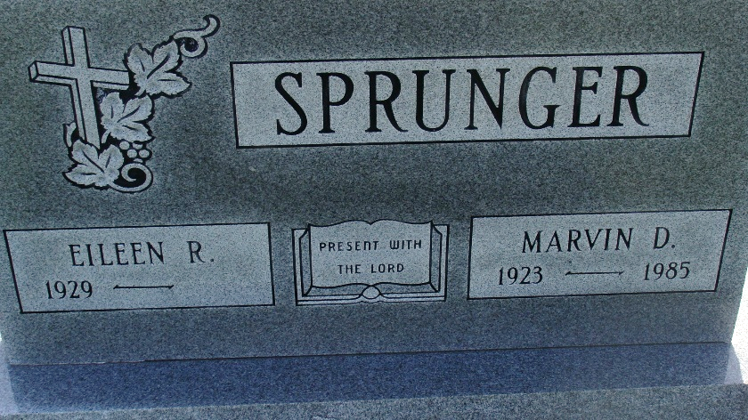
Photo by Alicia Kneuss

Indiana, U.S., Death Certificates, 1899-2017

Name Marvin D Sprunger
Gender Male
Race White
Marital Status Married
Age 61
Birth Date 11 Oct 1923
Birth Place Indiana
Death Date 20 Aug 1985
Death Place Berne, Adams, Indiana, USA
Death Registration Date 1985
Father Leonard F Sprunger
Mother Ellen Lehman
Spouse Eileen (Graber) Sprunger, informant
Burial M.R.E. 8/23/1988

