Martin Luther Sprunger
February 2, 1893 – March 8, 1971

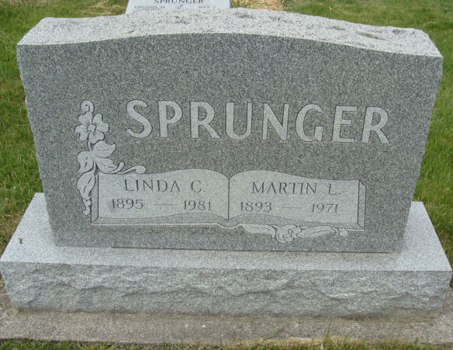
Photo by Alicia Kneuss

Martin Sprunger taken by death
Martin L. (Mike) Sprunger, 78, of Berne, who operated an ice cream business for many years, died at 10:25 a.m. Monday at the Adams County Memorial Hospital. Surviving are his wife, Linda; one son, two daughters, 17 grandchildren, one great-grandchild, and one sister.
Funeral services will be conducted at 2 p.m. Wednesday at the First Mennonite Church. Friends may call at the Yager Funeral Home after 3 p.m. today. He was a member of the Berne Chamber of Commerce, and a charter member of the Berne Rotary Club. Mr. Sprunger was appointed citizen of the year by the Berne Jaycees several years ago.
Decatur Daily Democrat, Adams County, Indiana
Tuesday, March 9, 1971
**

Rites Wednesday for Longtime Ice Cream Manufacturer

Martin L. (Mike) Sprunger, 78, 756 Van Buren Street, long a well-known businessman in Berne, died at 10:25 am today at the Adams County Memorial Hospital. Death was unexpected and was apparently due to a heart attack. He became ill at his home Saturday and was taken to the hospital late Saturday by Yager Ambulance. Mr. Sprunger had been the victim of several heart seizures earlier, but recovered and continued to operate his ice business.
Mr. Sprunger was affectionately known as “Ice Cream Mike” and manufactured Berne ice cream at his plant in the east part of the city for many years prior to discontinuing the business. Since then he has been dispensing ice from the plant to various local businesses as well as to area towns.
A member of the First Mennonite Church, Mr. Sprunger was active in civic affairs and was a former president of the Berne Chamber of Commerce of which he was a member. He also was a charter member of the Berne Rotary Club. The esteem in which he was held can be seen from the fact that one year he was Berne Citizen of the Year, an honor bestowed by the Berne Jaycees.
Mr. Sprunger was born February 2, 1893 in this community, a son of David and Regina Moser Sprunger. He was married April (cut off)

Date of Death: 1971; Date of Burial: March 15, 1971; Burial: MRE

Berne (IN) Library Heritage Room
MRE Obit Book 1966-1972
**

Indiana, U.S., Marriage Index, 1800-1941

Name M L Sprunger
Marriage Date 22 Apr 1917
Marriage Place Adams, Indiana, USA
Spouse Name Linda C Luginbill

