Martin Fredrick Sprunger
October 22, 1896 – February 11, 1980

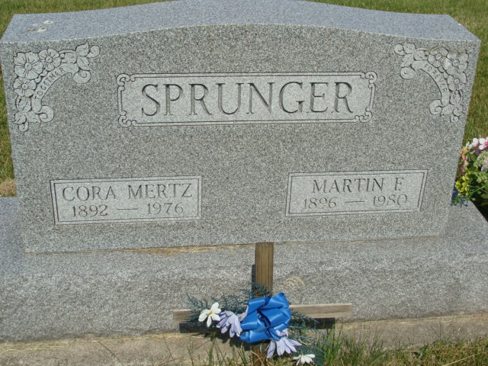
Photo by Alicia Kneuss

Indiana, U.S., Death Certificates, 1899-2017
Name Martin F. Sprunger
Gender Male
Race White
Marital Status Widowed
Age 83
Birth Date 22 Oct 1896
Birth Place Indiana
Death Date 11 Feb 1980
Death Place Decatur, Adams, Indiana, USA
Death Registration Date 1980
Father Simon Sprunger
Mother Rachel R. Sprunger
Informant Ed F. Sprunger, Decatur, IN
Burial M.R.E. Cemetery 2/14/1980

