Martha Nathalie (Gilliom) Sprunger
October 8, 1882 – August 9, 1970

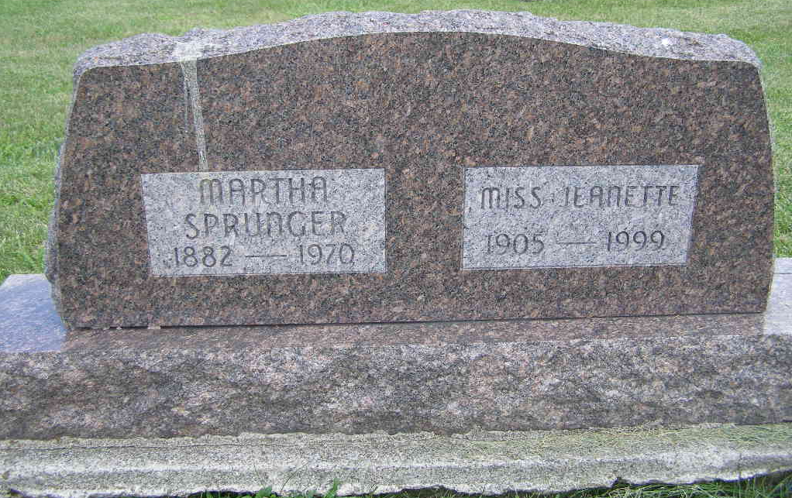
Photo by Shaunda Bedwell Opdycke
(back of husband Nathan & Caroline Sprunger stone)

Martha Sprunger dies at hospital
Mrs. Martha Sprunger, 88, of Swiss Village, Berne, wife of Nathan Sprunger, died at 8:55 p.m. Sunday at the Adams County Memorial Hospital. She was born in Berne Oct. 8, 1882, a daughter of Peter and Rachel Lehman-Gilliom.
She was a retired secretary for O. F. Gilliom Lincoln Life Insurance Agency at Berne. Mrs. Sprunger was a member of the First Mennonite Church.
Surviving is her husband; five stepsons, Irwin Sprunger of near Geneva, Rolland Sprunger of Indianapolis, and Les, Vincent, and Clyde Sprunger, of Berne; three stepdaughters, Mrs. Dorothy Fuhrman of Decatur, Miss Jeanette Sprunger of Berne, and Mrs. James (Lila) Miller of East Brunswick, N.J.; two sisters, Mrs. Menno E. (Hulda) Stauffer of Berne, and Miss Emma Gillion of Swiss Village; 23 step-grandchildren and 37 step-great-grandchildren.
Services will be held at 10 a.m. Wednesday at the Yager Funeral Home in Berne, with Rev. Gordon Neuenschwander officiating. Burial will be in MRE Cemetery. Friends may call at the funeral home after 2 p.m. Tuesday.
Decatur Daily Democrat, Adams County, Indiana
Monday, August 10, 1970
**

Wife of Nathan Sprunger Dies Late Sunday
Funeral Here Wednesday for Prominent Woman, 87

Mrs. Martha (Gilliom) Sprunger, 87, wife of Nathan Sprunger of Swiss Village, died unexpectedly at 9 pm Sunday at the Adams County Memorial Hospital where she had been taken Sunday afternoon. She became quite ill Sunday morning and her health had been failing the last several weeks. Death was attributed to a heart attack.
Mrs. Sprunger was the daughter of Peter and Rachel Lehman Gilliom, was born October 8, 1882, near Elkton, in Hickory County, Missouri. At the age of nine she came to Berne with the rest of her family.
In her late teens, she was baptized by the late Rev. S. F. Sprunger and joined the First Mennonite Church, in which she was active in various capacities. For some years she was a clerk in the local Fair Store, after which she attended Moody Bible Institute in Chicago and graduated from the Bible-Music courage. Also after graduating from a secretarial course at International Business College of Fort Wayne, she returned to the Moody Bible Institute, where she served as secretary to several of the professors for a period of eleven years. She then went to California, and served in the same capacity at the Bible Institute of Los Angeles for several years.
On returning to Berne, she was employed in the local office of the Lincoln National Life Insurance Company until her marriage to Nathan Sprunger on November 10, 1953. They lived in their home in Berne until the opening of Swiss Village in 1968, when they moved there and have since resided there.

Death: August 9, 1970; Burial: August 12, 1970
Buried: Lot 123, Original Platt

Berne (IN) Library Heritage Room
MRE Obits 1969 - 1972
**
Indiana, U.S., Death Certificates, 1899-2017

Name: Martha Sprunger [Martha Gilliom]
Gender: Female; Race: White; Age: 87; Marital Status: Married
Birth Date: 8 Oct 1882
Birth Place: Indiana
Death Date: 9 Aug 1970
Death Place: Decatur, Adams, Indiana, USA
Father: Peter Gilliom
Mother: Rachel Lehman
Spouse & informant: Nathan Sprunger
Burial: 9/12/1970, MRE

