Marjorie Ruth (Sprunger) Sprunger
August 28, 1935 – October 12, 2010

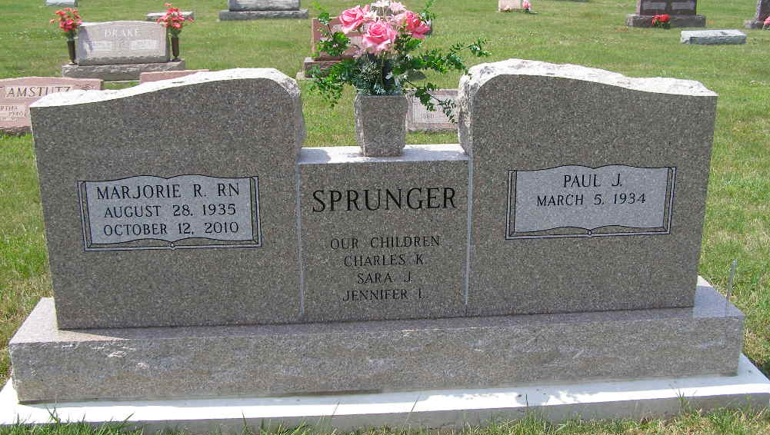
Photo by Shaunda Bedwell Opdycke

Marjorie “Marge” R. Sprunger, 75, of Berne, passed away at 11:20 am Tuesday, October 12, 2010 at Select Specialty Hospital, Fort Wayne. She was born in Berne on August 28, 1935 to Calvin A. and Lulu (Stuckey) Sprunger, both deceased. Marge graduated from Berne French High School in 1953 and Lutheran Nursing School in 1956. She was married to Paul J. Sprunger on September 22, 1957 in Berne.
Marge served as an RN at Caylor Nickel Clinic in Bluffton for two years, in Dr. Beaver’s Office in Berne for 18 years, for several other doctors, and at Swiss Village Nursing Home for seven years. Marge also worked at the Berne Public Library for 10 years and volunteered at Swiss Village, the Red Cross, and the Et Cetera Ecke charity resale store. She was a member of the Berne Trinity United Methodist Church, an active member of the United Methodist Women’s group, and served for many years on the church missions committee. Her hobbies included needlecraft, cooking, reading, and antique glass collecting.
She is survived by her husband Paul; two sisters, Jeanette (Kenneth) Heniser of Swiss Village, Berne, IN and Marcile (Dr. F.M.) Sellers of South Bend, IN; three children, Charles “Chuck” (Jacque) Sprunger of Saline, MI, Sara (Steve) Colter of Fairland, IN, and Jenny (J.D.) Collins of Hartford City, IN; and four grandchildren.
Visitation is from 2-8 pm on Friday, October 15 at Yager-Kirchhofer Funeral Home in Berne and from 9-10:30am on Saturday, October 16 at Berne Trinity United Methodist Church, followed by a funeral service at 10:30am at the church. Officiating is Pastor Mark Harris. Burial will be at the MRE Cemetery, Berne.
Memorials may be made to the Trinity United Methodist Church and designated for either the church missions fund or the Taylor University Lighthouse missions program.

Yager-Kirchhofer Funeral Home, Adams County, Indiana

