Marjorie C. (Baumgartner) Sprunger
February 3, 1917 – March 5, 1982

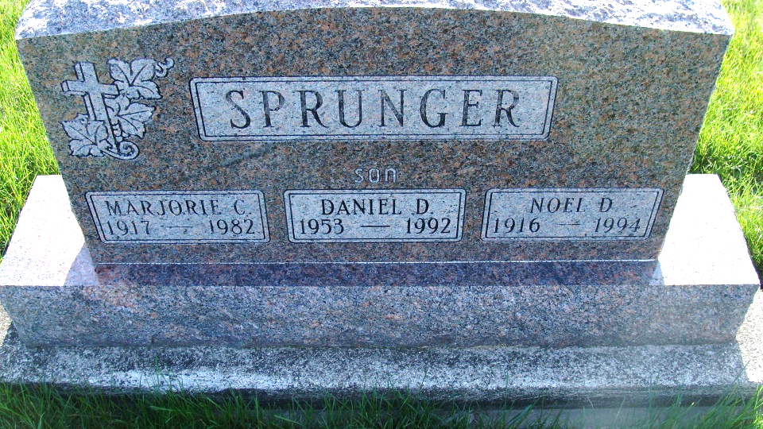
Photo by DSON1492

Indiana, U.S., Death Certificates, 1899-2017
Name Marjorie C. Sprunger
[Marjorie C. Baumgartner]
Gender Female
Race White
Marital Status Married
Age 65
Birth Date 3 Feb 1917
Birth Place Indiana
Death Date 5 Mar 1982
Death Place Indianapolis, Marion, Indiana, USA
Death Registration Date 1982
Father Elmer Baumgartner
Mother Bertha Lehman
Spouse Noel Sprunger, informant
Burial M.R.E. Cemetery 3/8/1982

