Marinel Kae (Striker) Sprunger
September 21, 1937 – June 20, 2019

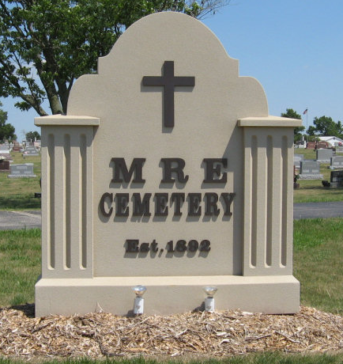
Photo by Tombstoner & Family

Marinel Kae Sprunger, 81, of Berne, Indiana passed away unexpectedly and peacefully Thursday afternoon, June 20, 2019 at Lutheran Hospital in Fort Wayne. She was born September 21, 1937 in Adams County, Indiana to Daniel & Esther (Bauman) Striker. Marinel was united in marriage to Earl Howard Sprunger on January 24, 1954 at First Mennonite Church. They were married for 65 years before Marinel’s passing.
Marinel was a member of the First Mennonite Church and also attended Calvary Bible Church. She enjoyed volunteering at the Swiss Heritage Village in Berne for many years. Marinel served on the committee that was instrumental in establishing the shuffle board courts at the Muselman Wellness Center at Swiss Village.
Marinel was self-employed as a painter and wallpaperer for 40 plus years.
Marinel was a very driven individual, hard-working, wonderful mother, wife, sister, aunt, grandmother, and great grandmother. She enjoyed the family time at the lakes and being outdoors mushroom hunting, gardening, and picking flowers. She also enjoyed her winters in Florida playing bocce, shuffleboard, cards, Mexican dominoes, and heading up the annual “fashion show”. Her travels were not limited to Florida, she and Earl traveled worldwide and especially enjoyed their time in Germany. Animals were always a big part of Marinel’s life and she was active with Operation Charlie Horse, the Arabian horse rescue in Adams County. She was able to adopt one of the rescued horses and continued to ride until she was 78 years old.
She is survived by her husband, Earl Howard Sprunger of Berne; three daughters, Gail (Don) Kuhn, Dana (Gerald) Schwartz, & Kenya (Rod) Habegger all of Berne; daughter-in-law, Angie Sprunger of Berne; nine grandchildren, David (Audry) Zuercher, Luke (Charlotte) Zuercher, Benjamin (Kate) Zuercher, Timothy (Lisa) Kuhn, Daniel (Heidi) Sprunger, Denise (James) Sprunger, Anie Habegger, Tawnie Habegger, & Heather Brown & 14 great-grandchildren Jocelyn, Isabelle, Faith, Cort, True, Ottilia, and Samuel Zuercher; Brendon, Colton, Alena, Dakota & Brock Sprunger, & Taylor & Chase Brown.
She was preceded in death by her son, Van Sprunger on December 25, 2014; sister, Shirley Worden; and two brothers, James & Claude Striker.
A Memorial Service will be held at 10:30 a.m. Tuesday, June 25, 2019 at Zwick & Jahn Funeral Home, Yager – Kirchhofer Chapel in Berne with Pastor Henry Schaadt and Pastor Mike Wertenberger officiating. Burial will follow at a later date at MRE Cemetery in Berne. Family & friends will be received from 2 to 8 p.m. Monday, June 24, 2019 at the Zwick & Jahn Funeral Home, Yager – Kirchhofer Chapel and one hour prior to the Memorial Service on Tuesday also at the funeral home.
Preferred memorials are to Indiana Resource Center for Autism; Swiss Heritage Village; Calvary Bible Church; or First Mennonite Church.

Zwick & Jahn Funeral Home, Adams County, Indiana
June 21, 2019

