Marianna (Moser) Sprunger
April 21, 1829 – June 1, 1894

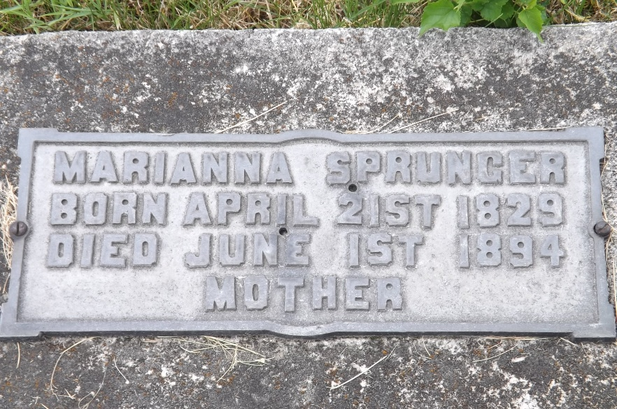
Photo by Jim Allen

Marianna A Moser from tree Middaugh-Vasquez Family Tree
Birth 21 Apr 1829 Landiswil, Bern, Switzerland
Marriage 5 Oct 1851 Thurgau, Switzerland
Residence 1880 Adams, Indiana, USA
Death 1 Jun 1894 Berne, Adams, Indiana, USA
Father Jakob S Moser (Born 1792)
Mother Anna Klay (Born 1788)
Spouse Peter Sprunger (1825-1898)
57554 People 9 Records 23 Sources
**

U.S., Family History Books

Name Marianna Moser
Birth Date 21 1829
Birth Place Putnam Co., O
Marriage Date 29 Nov 1851
Death Date 1 Jun 1894
Spouse Emanuel J Liechty
Peter Sprunger
Title Sprunger Family, p. 183
Author Willis E Hurr
5.1 Peter Sprunger 1-28-1825 - 11-12-1898
Peter was born in Munsterberg, Switzerland. He was married Nov. 29, 1851 to Marianna Moser from Landiswil. Marianna was born April 21, 1829 and died June 1, 1894. In 1852 they moved to America where in Adams Co., Ind. they bought a piece of forest land and established their lovely home, which was near the little town of Berne.

