Marianna (Lehmann) Sprunger
August 12, 1825 – March 7, 1907

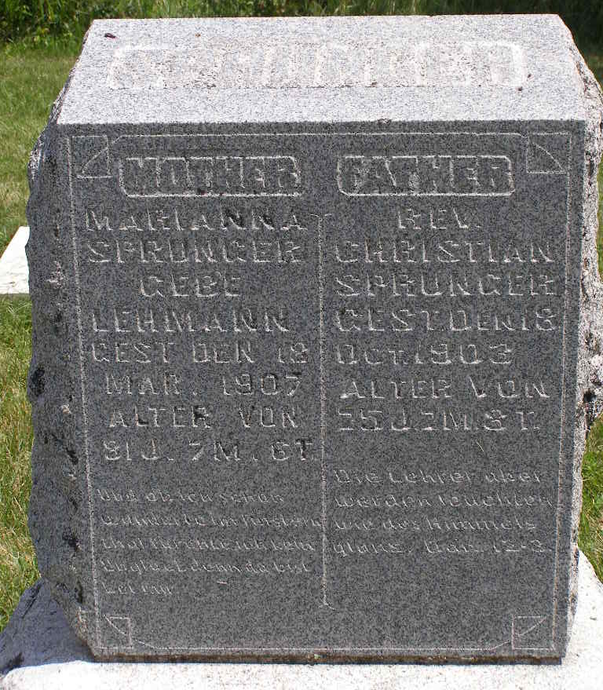
Photo by Shaunda Bedwell Opdycke

Maria Anna "Marianna" Lehmann Sprunger from tree Sprunger Family Tree
Birth 12 Aug 1825 Bern, Switzerland
Marriage 3 Jun 1852 Wayne, Monroe, Ohio, USA
Residence 1880 Adams, Indiana, USA
Death 7 Mar 1907 Berne, Adams, Indiana, USA
Father Peter P. Lehman (1780-1843)
Mother Katharina/Catharina Tschantz (1780-1843)
Spouse Rev. Christian B Sprunger (1828-1903)
17991 People 12 Records 26 Sources
**
U.S., Family History Books
Name Marianna Lehman
Gender Female
Birth Date Jul 1827
Marriage Date 3 Jun 1852
Death Date 7 Mar 1907
Father Peter
Spouse Christian Sprunger
Child Katharina Sprunger
Title The Sprunger Family, Descendants of Peter Sprunger, Born 1757, Including His Male Ancestral Line to Hans Sprunger, Born 1565-1575
Author Herr, Willis Eldon, p. 146
4.7 Christian Sprunger (4-10-1928 - 10-18-1903)
Christian was born in Moutier, Switzerland, on June 3, 1852 (sic). He was married to Marianna Lehman, daughter of Peter. In 1852 they moved to America where they spent a few weeks in Wayne Co., Ohio and then moved to Adams Co., Ind. where he was chosen as minister by the congregation and in 1868 he was ordained elder, Marianna was born in July 1827 and died March 7, 1907.

