Maria (Luginbill) Moser Sprunger
November 11, 1840 – December 14, 1872

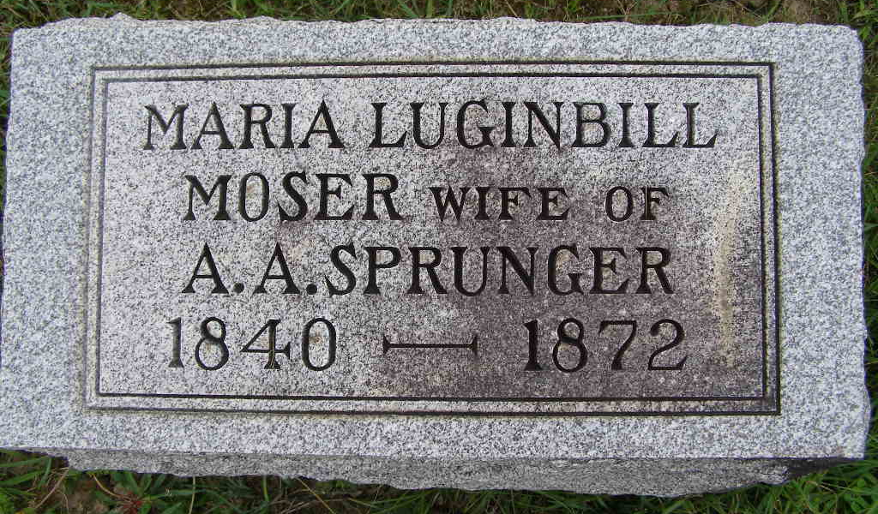
Photo by Shaunda Bedwell Opdycke

Maria Luginbuhl from tree Schmitz/Welty Family Tree

Birth 11 Nov 1840 Putnam, Ohio, USA
Marriage 11 Jan 1866
Residence 1870 Monroe City, Adams, Indiana, USA
Death 14 Dec 1872 Berne, Adams, Indiana, USA
Father Johannes C Luginbuhl (1803-1873)
Mother Anna Marie Diller (1798-1853)
Spouse Ulrich Moser (1834-1864)
Spouse Abraham A Sprunger (1841-1906)
5707 People 2 Records 4 Sources
**

U.S., Family History Books

Name Maria Moser
Gender Female
Marriage Date 11 Jan 1866
Death Date 14 Dec 1872
Spouse Abraham A Sprunger
Title The Sprunger Family, 1757-1972: in Three Parts From Manuscripts, Author Lochner, Electa I. Baltzell (Electa Iantha Baltzell), 1895- , p. 33
10. Abraham A. Sprunger born February 22, 1841 on the Corgemontberg, Switzerland, married November 22, 1862 to Anna Sprunger, daughter of Abraham Sprunger, in Adams County, Indiana. Anna died April 4, 1864. Then he married, second time, January 11, 1866 to widow Marie Moser. On December 14, she died. The third time, he married March 3, 1873 to Magdalena Neuenschwander. They lived in Adams County, Indiana. He was a farmer and a maker of wood handles.
Children by second wife, Maria Moser.
Lidia b. November 26, 1866
Samuel b. November 21, 1868
Emma b. December 3, 1870

