Marguerite R. (Michaud) Sprunger
September 24, 1920 – December 29, 2004

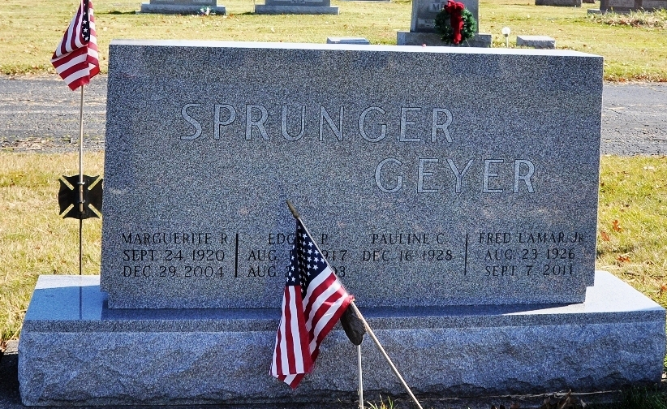
Photo by Deb Curry

Marguerite Sprunger, 84, Berne, died at her residence at Swiss Village Wednesday, Dec. 29, at 10:55 a.m. Born Sept. 24, 1920 in Adams County to Chester T. and Frances Reusser Michaud, she married Dr. Edgar P. Sprunger Nov. 24, 1948 in Berne. He preceded her in death in 2003.
A member of West Missionary Church, she served as church
organist for many years. She was formerly employed by Berne Furniture Co. and later served as secretary to the president of Huntington College. She also taught piano.
Survivors include two sons, Patrick and Reed, both of Fort Wayne; two daughters, Mrs. Barry (Andrea) McCune, Van Wert, Ohio, and Mrs. Jeff (Lisa) Nickel, Corn, Okla.; a sister, Mrs. Fred (Pauline) Geyer, Fort Wayne; and eight grandchildren.
Services at 2 p.m. Sunday will be held at West Missionary Church under the direction of Keith Rupp with burial to follow at M.R.E. Cemetery in Berne. Calling hours are 3 to 5 p.m. and 6 to 8 p.m. Saturday at ​Swiss Village Chapel and one hour prior to services Sunday at the church.
Memorials may be made to West Missionary Church, Swiss
Village Endowment Fund and Gideon's International.
Bluffton News Banner, Wells County, Indiana
Thursday, December 30, 2004
**

MARGUERITE SPRUNGER, 84, of Berne, died Wednesday, Dec. 29, 2004. Surviving are son, Patrick (wife, Pam) Sprunger of Fort Wayne; daughter, Andrea (husband, Rev. Barry) McCune of Van Wert, Ohio; son, Reed G. (wife, Darla) Sprunger of Fort Wayne; daughter, Lisa (husband, Jeff) Nickel of Corn, Okla. sister, Mrs. Fred (Pauline) Geyer of Fort Wayne; and eight grandchildren. She was preceded in death by her husband, Dr. Edgar P. Funeral service is 2 p.m. Sunday at West Missionary Church, Berne, with calling one hour prior to service. Calling also from 3 to 5 and 6 to 8 p.m. Saturday at Swiss Village Chapel, Berne. Burial at M.R.E. Cemetery. Memorials to Swiss Village Endowment Fund, West Missionary Church or Gideon's International. Arrangements by Yager- Kirchhofer Funeral home, Berne.

Journal Gazette, The (Allen County, Indiana)
Thursday, December 30, 2004

