Margaret Pearl (Parr) Sprunger
August 11, 1928 – February 20, 2019

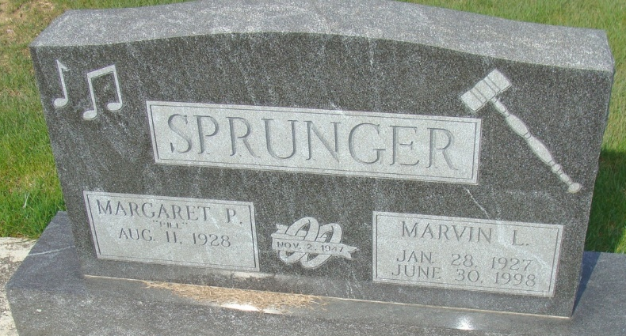
Photo by Alicia Kneuss

Margaret P. "Pill" Sprunger, 90, of Berne, IN, passed away on Wednesday, February 20, 2019, at Adams Memorial Hospital. Margaret was born in Berne on August 11, 1928, the late Bert W. and Martha E. (Miller) Parr. On November 2, 1947, she married Marvin L. Sprunger. He preceded her in death in 1998.
Margaret was a member of Bethel Brethren Church-Berne. She played piano and keyboard for many events, worked on the Election Board and worked at Haggard-Sefton-Hirschy & Zelt Funeral Home for many years. She retired from Micro Precision as an accounting clerk.
Margaret is survived by 2 sons, Duane (June) Sprunger and Randy (Vicki) Sprunger both of Berne; a daughter, Nancy (Stan) VanEmon of Berne; 2 sisters, Judy Dye of Berne and Donna Tiede of Georgetown, TX; 4 grandchildren and 4 great grandchildren. She was preceded in death by 2 brothers, Bob and Keith Parr and 2 grandchildren.
Visitation will be from 4:00-7:00 p.m. Friday, February 22, 2019 at Swiss Village in Berne.
Funeral Service will be held at 10:30 a.m. Saturday, February 23rd at Bethel Brethren Church-Berne with calling from 9:00-10:00 a.m. Officiating will be Pastor Joe Nass. Burial will be in MRE Cemetery, Berne.
Memorials are to MS Research or Grace College Music Dept.
Arrangements are handled by Haggard-Sefton-Hirschy & Zelt Funeral Home.

Haggard, Sefton & Zelt Funeral Home, Adams County, Indiana
February 21, 2019

