Marcus Sprunger
February 19, 1899 – May 1, 1976

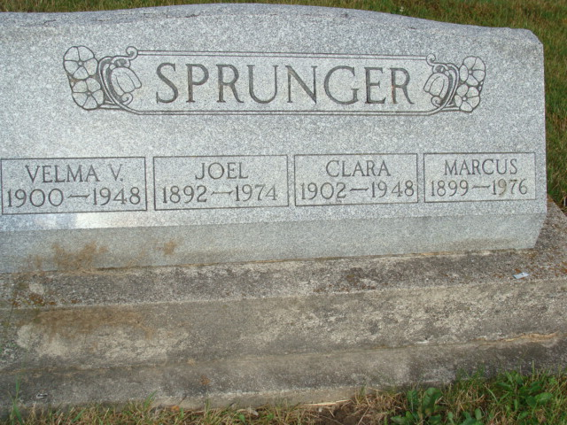
Photo by Alicia Kneuss

Indiana, U.S., Death Certificates, 1899-2017

Name Marcus Sprunger
Gender Male
Race White
Marital Status Married
Age 77
Birth Date 19 Feb 1899
Birth Place Indiana
Death Date 1 May 1976
Death Place Berne, Adams, Indiana, USA
Death Registration Date 1976
Father Ulrich Sprunger
Mother Anna Liechty
Spouse Barbara (Amstutz) Sprunger, informant
Burial M.R.E. 5/4/1976
**

Marcus Sprunger from tree Julie Frederick Family Tree

Birth 19 Feb 1899 Berne, Adams, Indiana, USA
Marriage 24 Sep 1949 Allen, Indiana, USA
Residence 1959 Decatur, Adams, Indiana, USA
Death 1 May 1976 Berne, Adams, Indiana, USA
Father Ulrich Sprunger (1860-1932)
Mother Anna Liechty (1861-1945)
Spouse Clara Nichols (1902-1948); Barbara Amstutz (1902-1985)
14112 People 15 Records 31 Sources
**
Indiana, U.S., Marriages, 1810-2001
Name Marcus Springer
Gender Male
Race White
Event Type Marriage Registration (Marriage)
Birth Place Indiana
Marriage Date 14 Sep 1920
Marriage Place Berne, Indiana, United States
Residence Place Berne
Father Ulrich Springer
Mother Anna Luchly
Spouse Clara Nichols
Officiator J C G
Page 74

