Mahala (Schenbeck) Sprunger
October 9, 1877 – February 1943

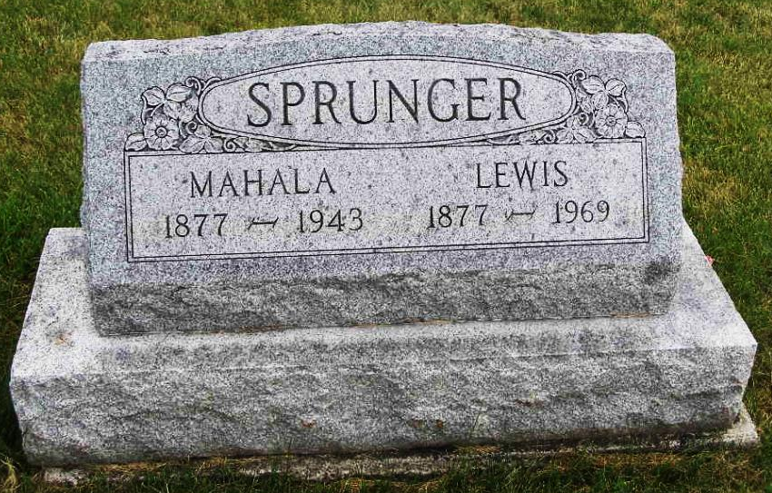
Photo by Shaunda Bedwell Opdycke

Indiana, U.S., Death Certificates, 1899-2017
Name Mahala Schenbeck Sprunger
[Mahala Schenbeck Schenbeck]
Gender Female
Race White
Marital Status Married
Age 65y 4m
Birth Date 9 Oct 1877
Birth Place Adams County, Indiana
Death Date 9 Feb 1943
Death Place Berne, Adams, Indiana, USA
Death Registration Date 1943
Father John Schenbeck
Mother Barbara Huser
Spouse Lewis Sprunger, age 65, informant
Burial MRE 2-12-1943

