Mae Bertha (Stauffer) Sprunger
October 3, 1891 – November 7, 1966

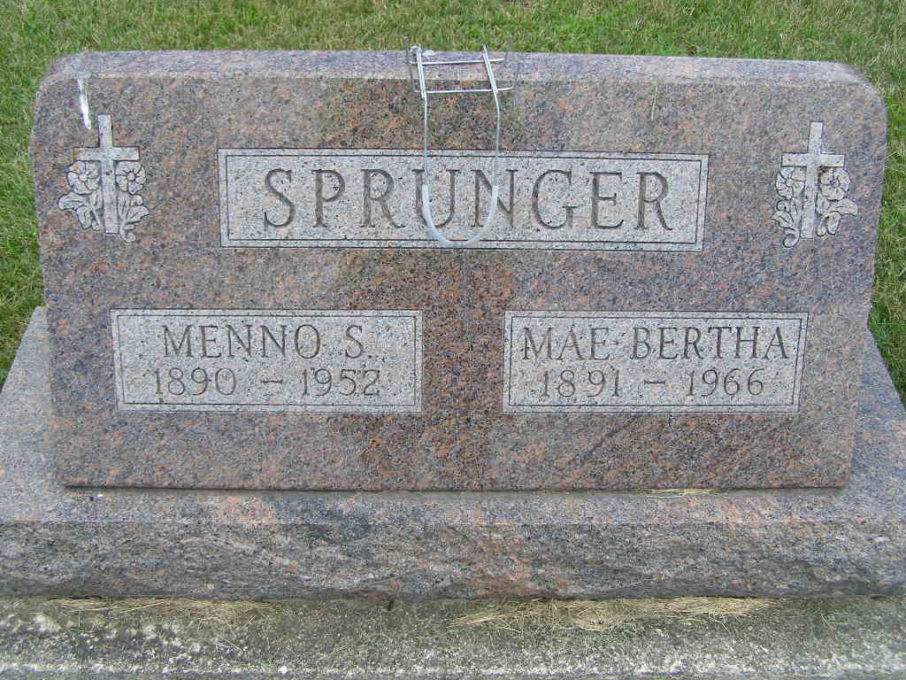
Photo by Alicia Kneuss

Mae Sprunger Dies Monday
Yager Funeral Home Site For Rites Thursday PM

Funeral services for Mrs. Mae Bertha Sprunger, 75, a lifelong resident here who died at the Cooper Rest Home at Decatur at 1 pm Monday will be held Thursday at 2 pm at the Yager Funeral Home here. The Rev. Kenneth Overmeyer, pastor of the Trinity EUB
Church of which Mrs. Sprunger was a faithful member, will officiate. Burial will be in the MRE Cemetery.
Mrs. Sprunger had been failing in health since July 2, 1965 and was a patient at the Adams County Memorial Hospital many months before she was moved to the rest home.
She was born in Berne October 3, 1891, a daughter of Ulysses and Kathryn GerigStauffer, and was married to Menno Sprunger March 25, 1917. Her husband preceded her in death in 1952. They had resided on E. Water Street for many years.
Surviving are four sons, Weldon L. Sprunger of Pondagora, Fla., Leland W. Sprunger of Philadelphia, and Loren V. and Paul J. Sprunger, both of Berne; three daughters, Mrs. Kenneth (Janice) Hoffman of Monroe, Mrs. James (Evelyn) Hart of near Monroe, and
Mrs. Leland (Areta) Bishop of Berne; one brother, William E. Stauffer of Fort Wayne; 21 grandchildren and seven great-grandchildren.

Date of Death: November 8, 1966; Date of Burial: November 10, 1966
Burial on: Lot 162 Original Platt

Berne Heritage Room
MRE Obits 1966-1972, image 040
**

Indiana, U.S., Death Certificates, 1899-2017

Name Mae Mertha Sprunger
[Mae Mertha Stauffer]
Gender Female
Race White
Age 75
Marital Status Widowed
Birth Date 30 Oct 1891
Birth Place Indiana
Death Date 7 Nov 1966
Death Place Decatur, Adams, Indiana, USA
Father Ulysses Stauffer
Mother Kathryn Gerig
Informant: Paul Sprunger; son; Berne, Indiana
Burial: November 10, 1966; MRE; Berne, Indiana

