Luella Kathryn Sprunger
May 10, 1910 – December 9, 1929

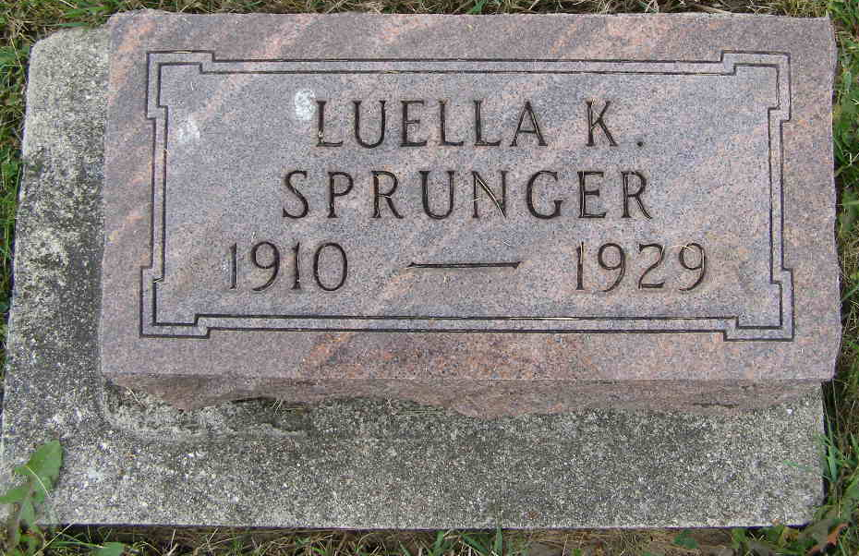
Photo by Shaunda Bedwell Opdycke

Luella and Luetta, twin daughters of Mr. and Mrs. D. J. Sprunger, have been sick for about four weeks. Luetta has improved considerably, but Luella who was taken with an attack of pneumonia is no better.

Berne Witness, Adams County, Indiana
Friday, Jan. 13, 1911
**

Indiana, Death Certificates, 1899-2011

Name: Luella Kathryn Sprunger
Gender: Female
Race: White
Age: 19
Marital Status: Single
Birth Date: 10 May 1910
Birth Place: Indiana
Death Date: 9 Dec 1929; tuberculosis
Death Place: Monroe, Adams, Indiana, USA
Father: Daniel G. Sprunger
Mother: Ella Reusser
Informant: D. J. Sprunger of Berne, IN
Burial: Dec. 11, 1929 MRE Cemetery

