Lucille (Winteregg) Sprunger
July 10, 1914 – March 1, 2011

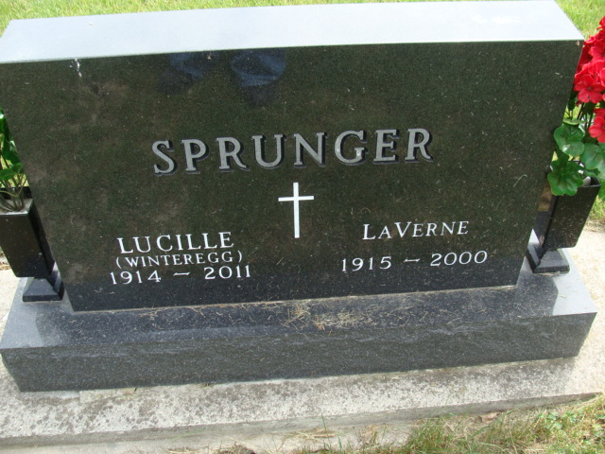
Photo by Alicia Kneuss

Lucille K. Sprunger. 96, a resident of Berne, Indiana passed away at 12:50 a.m. Tuesday, March 1, 2011 at the Swiss Village Retirement Community in Berne. Lucille was born on July 10, 1914 in Hesperia, Michigan the daughter of Henry and Cassie (Schindler) Winteregg, both deceased. She married LaVerne Sprunger on June 27, 1936 and he preceded her in death in 2000.
Lucille was a member of the First Missionary Church in Berne where she was active in church music ministries. She was a homemaker and an Avon Products Representative. Lucille was known for her wonderful sense of humor and quick wit. She loved caring for and raising flowers.
Lucille’s family and her faith in God were very important to her. She especially enjoyed attending her grandchildren’s activities. Lucille is survived by a daughter, Roxanne Leichty of Newport News, Virginia; a daughter, Lana (Ted) Schwartz Berne; grandchildren; Marnie Leichty, Cassie Anderson Leichty, Christopher (Laura) Leichty, Jason (Becky) Schwartz, Lendon (Tiffany) Schwartz, and great-grandchild-ren; Bryn Leichty, Tavish Anderson-Leichty, Linus Leichty, Laramie, Ella, Julianne, and Malia Schwartz, and Kiptyn Schwartz.
Lucille was preceded in death by a sister, Olive Liechty.
Funeral services will be held at 2:00 p.m. Sunday March 6, 2011 at the Swiss Village Chapel with the Pastor Max Haines officiating. Interment will be in the M.R.E. Cemetery of rural Berne. Family and friends will be received from 3:00 – 8:00 p.m. Saturday, March 5, 2011 at the Swiss Village Chapel and one hour prior to the funeral service on Sunday. Preferred memorials are to the First Missionary Church Music Ministry or Family Hospice of Northeast Indiana.

Yager-Kirchhofer Funeral Home, Adams County, Indiana

