Lucile (Laisure) Sprunger
October 15, 1906 – March 31, 1991

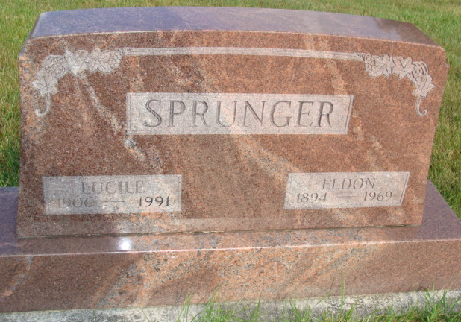
Photo by Alicia Kneuss

Lucille Sprunger, 84, Berne, died at 10:25 p.m. Sunday in Swiss Village, her residence since July 6, 1981. She was a former resident of Bluffton. She was born on October 15, 1906 in Adams County to Merle and Elizabeth Smith Laisure and married Eldon E. Sprunger on September 25, 1926; he died July 1969. She was a homemaker and a member of Bluffton United Church of Christ.
Surviving are an uncle, Alonzo Smith, route 1, Monroe, and four cousins: Mrs. J. Robert (Chloe) Myers, Berne; Chester Smith and Mrs. Howard (Eloise) Nussbaum, both of Monro; and Lester Smith, route 8, Decatur.
Funeral services will be at 10:30 a.m. Wednesday in Yager-Kirch-hofer Funeral Home, Berne, with burial in MRE Cemetery, Berne. Visiting hours are 3-9 p.m. Tuesday and 9-10:30 a.m. Wednesday. Preferred memorials are to Swiss Village.

Decatur Daily Democrat, Adams County, Indiana
Monday, April 1, 1991

