Lowell Lagrand Sprunger
June 23, 1912 – May 28, 1992

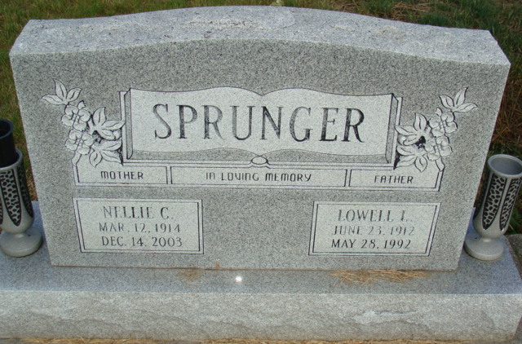
Photo by Alicia Kneuss

Indiana, U.S., Death Certificates, 1899-2017

Name Lowell L Sprunger
Gender Male
Race White
Marital Status Married
Age 79
Birth Date 23 Jun 1912
Birth Place Adams County, Indiana
Death Date 28 May 1992
Death Place Fort Wayne, Allen, Indiana, USA
Death Registration Date 1992
Father Jonas Sprunger
Mother Zilla Gilliom
Spouse Nellie (Jones) Sprunger, informant
Burial 5/31/1992 M.R.E.

