Lorine (Habegger) Sprunger
November 29, 1899 – June 16, 1996

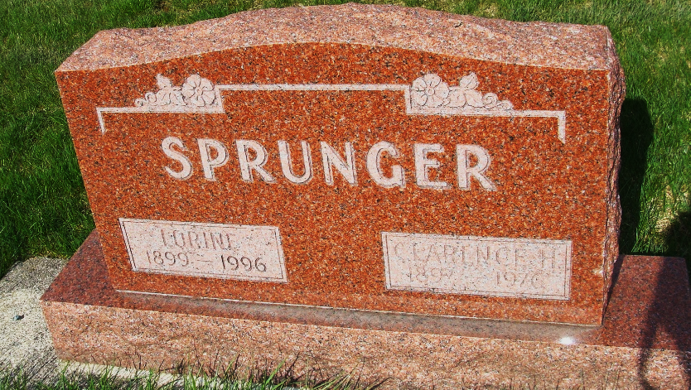
Photo by Alicia Kneuss

LORINE SPRUNGER, 96, of Berne, died Sunday at Swiss Village in Berne. The Adams County native was a homemaker. Surviving are her daughters, Juanita E. Herman of Syracuse, Jacqueline Smith of Anderson, Donna Mae Sprunger of Hammond and Jean L. Habegger of Berne; sons, Delbert D. and Logan C., both of Berne; 20 grandchildren; and 39 great-grandchildren. Her husband, Clarence H., died in 1976.
Services are 10:30 a.m. Wednesday at First Mennonite Church in Berne. Calling is 2 to 8:30 p.m. Tuesday at Yager-Kirchhofer Funeral Home in Berne. Burial is in MRE Cemetery, Berne.

News-Sentinel, The (Allen County, Indiana)
Monday, June 17, 1996
**
Indiana, U.S., Death Certificates, 1899-2017
Name Lorine Sprunger
[Lorine Habegger]
Gender Female
Race White
Marital Status Widowed
Age 96
Birth Date 29 Nov 1899
Birth Place Adams County
Death Date 16 Jun 1996
Death Place Berne, Adams, Indiana, USA
Death Registration Date 1996
Father Samuel A Habegger
Mother Anna Stauffer
Informant Delbert Sprunger, son
Burial 6/19/1996 M.R.E.

