Loren Jonas Sprunger
August 15, 1918 – August 27, 1920

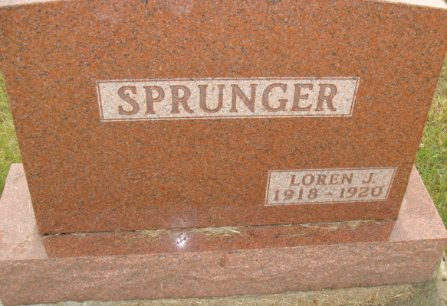
Photo by Alicia Kneuss

Indiana, U.S., Death Certificates, 1899-2017

Name Lorene Jonas Sprunger
Gender Male
Race White
Marital Status Single
Age 2y 0m 12d
Birth Date 15 Aug 1918
Birth Place Adams County, Indiana
Death Date 27 Aug 1920
Death Place Monroe, Adams, Indiana, USA
Cause of death accidental drowning
Death Registration Date 1920
Father Jonas Sprunger, informant
Mother Zilla Gilliom
Burial M.R.E. 8/30/1920
**

Indiana, U.S., Birth Certificates, 1907-1944

Name Loren Jonas Sprunger
Gender Male
Birth Date 15 Aug 1918
Birth Place Monroe, Adams, Indiana, USA
Father Jonas Sprunger, age 35
Mother Zilla Gilliom, age 31, 5 of 5 children living
Certificate Number 39912
Roll number 45385_539593
Volume Range 79 - 88

