Logan C. Sprunger
December 20, 1932 -

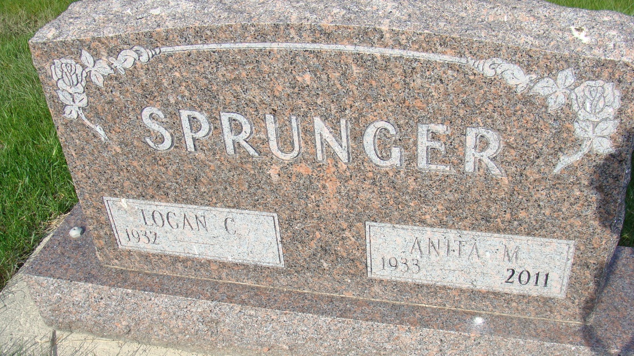
Photo by Alicia Kneuss

Indiana, U.S., Marriages, 1810-2001

Name Logan Sprunger
Gender Male
Race White
Age 19
Event Type Marriage Registration (Marriage)
Birth Date 20 Dec 1932
Birth Place Berne, Indiana
Marriage Date 6 Jun 1951
Marriage Place Decatur, Indiana, United States
Residence Place Berne, Indiana
Father Clarence Sprunger
Mother Lorine Habegger Sprunger
Spouse Anita Kennel
Officiator Edward F Jaberg
Page 638

