Linda Cora (Luginbill) Sprunger
March 18, 1895 – December 22, 1981

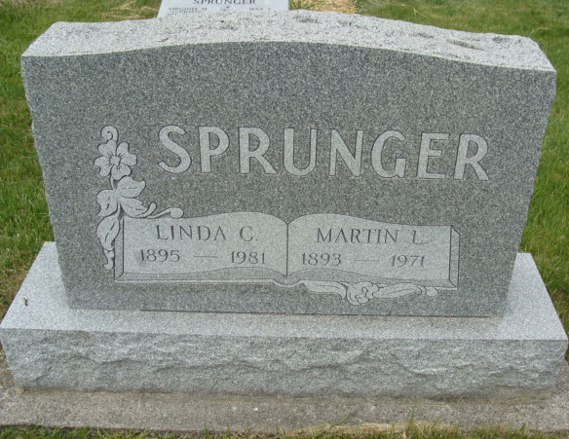
Photo by Alicia Kneuss

Indiana, U.S., Death Certificates, 1899-2017

Name Linda C. Sprunger
[Linda C. Luginbill]
Gender Female
Race White
Marital Status Widowed
Age 86
Birth Date 18 Mar 1895
Birth Place Kansas
Death Date 22 Dec 1981
Death Place Decatur, Adams, Indiana, USA
Father Adam Luginbill
Mother Mary Schmidt
Informant Mrs. Richard Beitler
Burial M.R.E. 12/26/1981
**

Indiana, U.S., Marriages, 1810-2001

Name Linda Cora Luginbill
Gender Female
Race White
Age 22
Birth Date 18 Mar 1895
Birth Place Kansas
Marriage Date 20 Apr 1917
Marriage Place Indiana, United States
Residence Place Berne, Indiana
Father Adam Luginbill
Mother Mary Schmidt
Spouse Martin L Sprunger
Page 192

