Lillian N. (Yoss) Sprunger
February 25, 1901 – June 22, 1979

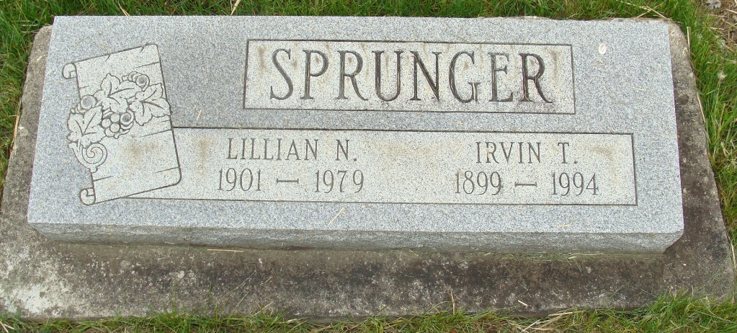
Photo by Alicia Kneuss

Lillian Sprunger

Mrs. Irvin T. (Lillian) Sprunger, 78, died Friday at 12:30 p.m. 1.5 miles west of Geneva following a one-car accident. She lived on Route 2, Geneva and was a lifetime resident of Adams County. She was a member of the First Missionary Church.
Born in Wabash Township, Adams County, on February 25, 1901, she was the daughter of Fred and Leah (Lehman) Yoss. She was married on August 23, 1923 to Irvin T. Sprunger, who survives.
Other survivors include: a daughter, Mrs. Lawrence B. (Julia) McCullough, Route 1, Monroe; three sisters, Mrs. Cora Fennig, Swiss Village, Berne; Mrs. Blondie Doty, Fort Wayne; and Mrs. Carl (Sophie) Faulkner, Kentucky; and a brother, Paul Yoss, Route 2. Geneva.
Services were held at 10 a.m. today at the First Missionary Church. Rev. James Johnson officiated with burial following in the MRE Cemetery.
Preferred memorials are to the church.

Unknown newspaper clipping

