Lillian Alda (Mettler) Sprunger
April 18, 1901 – December 9, 1969
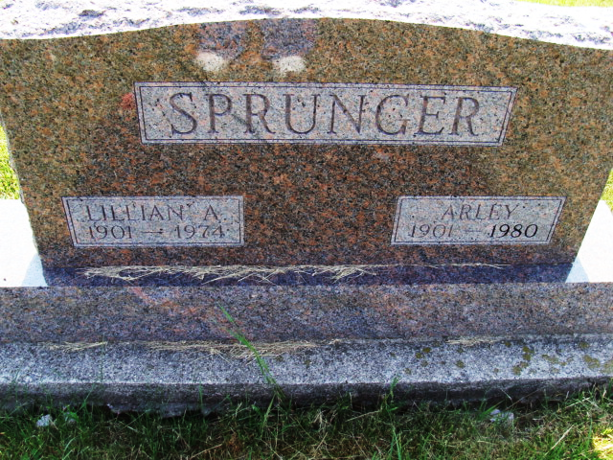
Photo by Alicia Kneuss

Wife of Arley Sprunger Dies Late Wednesday
Mrs. Lillian Sprunger, 73, wife of Arley Sprunger, 355 Compromise Street, Berne, died at 6:30 p.m. Wednesday at Lutheran Hospital in Fort Wayne following an illness of more than two years. Death is attributed to cancer.
A lifelong resident of this community, Mrs. Sprunger was born April 18, 1901, in Wabash Township, the daughter of David D. and Lydia Schindler Mettler. She was married to Arley Sprunger July 15, 1923, at the home of his wife’s parents. The couple celebrated their golden wedding anniversary last July. Mrs. Sprunger was a member of the First Mennonite church.
Surviving in addition to the husband are a daughter, Mrs. Loren (Ardus Jean) Sprunger, Fort Wayne; two sons, Rev. Hugh David Sprunger, a missionary in Taiwan and Dr. Keith L. Sprunger, North Newton, Kansas; 11 grandchildren; two sisters, Mrs. Carl (Nora) Flueckiger, near Geneva and Mrs. Hiram (Clara) Nussbaum, Berne, and a brother, Reuben T. Mettler near Geneva. A sister, Esther, is deceased.
The body is at the Yager Funeral Home where friends may call until 1 p.m. Saturday. The body will then be taken to the church for services at 2 p.m. Saturday with Rev. Kenneth Bauman officiating. Burial will be in the M.R.E. Cemetery.
Berne (IN) Library Heritage Room
1973-1984 MRE Obit Book, image 54

