Lila (Lehman) Sprunger
February 18, 1892 – June 3, 1955

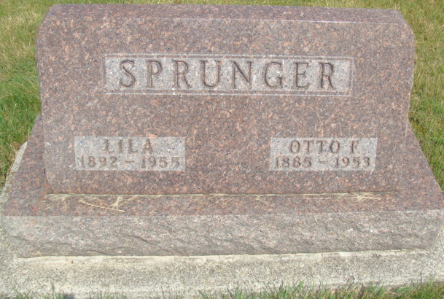
Photo by Alicia Kneuss

Mrs. Lila Sprunger Is Taken By Death
Funeral Services Monday Afternoon

Mrs. Lila Sprunger, 63, a native of Monroe Township, died at 2:20 o’clock Friday afternoon at the Clinic Hospital in Bluffton, following a heart attack suffered at her home in that city Thursday night.
Mrs. Sprunger had resided in Wells County since 1926 and was a member of the First Evangelical and Reformed Church in Bluffton. Her husband, Otto Sprunger, preceded her in death.
Surviving are five sons, Orison Sprunger of Berne, Fredrick and Adrian Sprunger of Bluffton, the Rev. Vaughn Sprunger of Portsmouth, O., and Curtis Sprunger, at home; 13 grandchildren; three brothers, Amos Lehman of Monroe, Mennas Lehman of Angola and Wilbur Lehman of Berne, and a sister, Mrs. Eli Baumgartner of Berne.
The body was removed to the Thoma Funeral Home in Bluffton, where friends may call after 5 o’clock this evening. At noon Monday it will be taken to the First Evangelical and Reformed Church for services at 2 p.m. Burial will be at the MRE Cemetery.

Adams County (IN) Historical Museum
1955 March-April 1958 Scrapbook, image 19
Handwritten-Sat. June 4, 1955
**

Indiana, U.S., Death Certificates, 1899-2017

Name Lila Sprunger (indexed as Spenger)
[Lila Lehmon]
Gender Female
Race White
Marital Status Widowed
Age 63
Birth Date 18 Feb 1892
Birth Place Indiana
Death Date 3 Jun 1955
Death Place Bluffton, Wells, Indiana, USA
Death Registration Date 1955
Father Peter Lehman
Mother Christina Lutimbill
Informant blank space
Burial 6/6/1955 MRE Cemetery

