Levi A. Sprunger
November 11, 1863 – June 1945

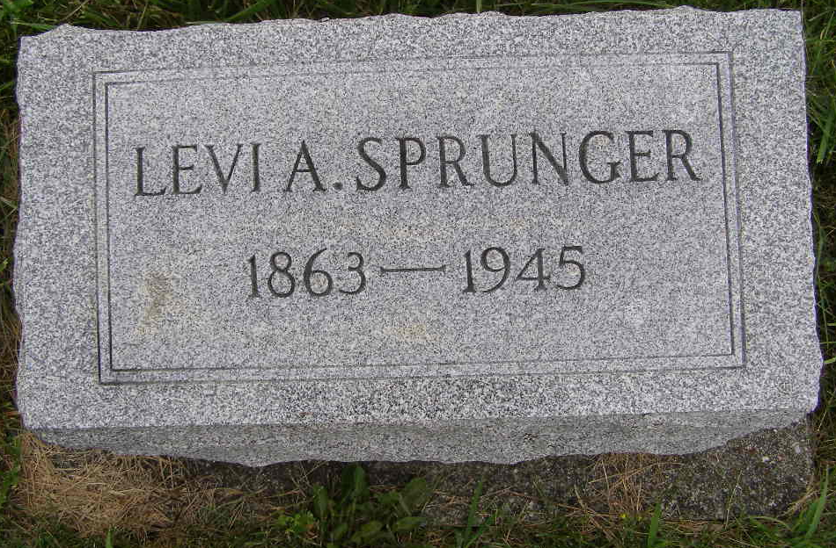
Photo by Shaunda Bedwell Opdycke

Indiana, U.S., Death Certificates, 1899-2017

Name Levi A Sprunger
Gender Male
Race White
Marital Status Married
Age 81y 7m 7d
Birth Date 1 Nov 1863
Birth Place Berne Adams Indiana
Death Date 8 Jun 1945
Death Place Berne, Adams, Indiana, USA
Death Registration Date 1945
Father Abraham A Sprunger b. Switzerland
Mother Anna Sprunger b. Switzerland
Spouse Mathilda (Baumgartner) Sprunger, age 75
Informant John Henry Sprunger, Berne, IN
Burial 6/11/1945 M.R.E. Cemetery

