Leslie L. Sprunger
December 14, 1909 – March 19, 1993

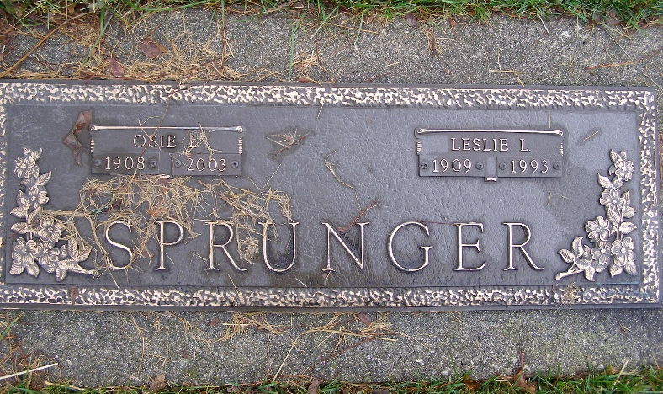
Photo by Shaunda Bedwell Opdycke

LESLIE SPRUNGER, 83, of Berne died yesterday at Swiss Village Nursing Care Unit, Berne. He was the former co-owner of Moser Motors Ford in Berne. Surviving are his wife, Osie; sons Jerry of Berne and Jim of Pandora, Ohio; daughter Janean Moser of Berne; sisters Jeanette Sprunger of Berne and Lila Miller of Camp Hill, Penn.; and brothers Clyde and Vincent of Berne and Irvin of Geneva; and several grandchildren. Services will be 11 a.m. Monday at First Missionary Church in Berne, where calling begins an hour before the service. Calling also is from 2 to 5 and 7 to 9 p.m. tomorrow and 8 to 9:30 a.m. Monday at Yager-Kirchhofer Funeral Home in Berne. Burial will be in M.R.E. Cemetery, Berne.

News-Sentinel, The (Allen County, Indiana)
Saturday, March 20, 1993
**
Indiana, U.S., Death Certificates, 1899-2017
Name Leslie L Sprunger
Gender Male
Race White
Marital Status Married
Age 83
Birth Date 14 Dec 1909
Birth Place Palisade, Nebraska
Death Date 19 Mar 1993
Death Place Berne, Adams, Indiana, USA
Father Nathan Sprunger
Mother Caroline Scheidegger
Spouse Osie (Hiestan) Sprunger
Informant Jerry Sprunger, son
Burial M.R.E. Cemetery 3/22/1993

