Leola E. (Simon) Sprunger
June 19, 1913 – December 17, 1980
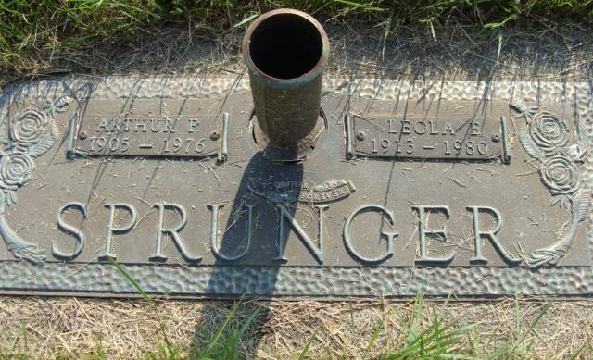
Photo by Alicia Kneuss

Indiana, U.S., Marriages, 1810-2001

Name Leola E Simon
Gender Female
Race White
Age 28
Event Type Marriage Registration (Marriage)
Birth Date 19 Jun 1913
Birth Place Adams, Indiana
Marriage Date 24 May 1941
Marriage Place Indiana, United States
Residence Place Berne, Indiana
Father Arnold Simon
Mother Flora Myers
Spouse Arthur F Sprunger
Page 237
FHL Film Number 002321634
**

Florida, U.S., Death Index, 1877-1998

Name Leola Sprunger
Race White
Age at Death 67
Birth Date 19 Jun 1913
Death Date 17 Dec 1980
Death Place Indian River, Florida, United States

