Leo N. Sprunger
May 29, 1899 – April 17, 1977

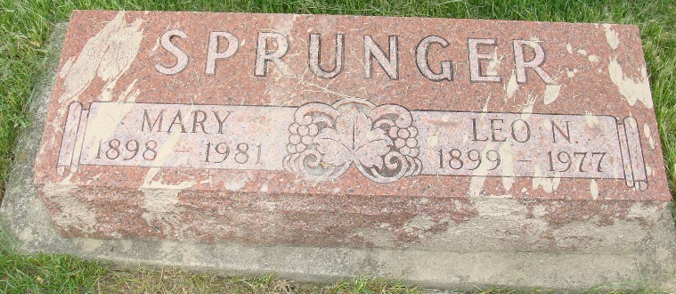
Photo by Alicia Kneuss

Leo N. Sprunger, 77, a resident of this community for 67 years, died in his sleep early Sunday at the Convalescent Home at Keokuk, Iowa. Time of death was at 6:45 a.m.
Mr. Sprunger resided in Zephyr, Florida until January 30 of this year when he went to Iowa. He lived in Monroe for 10 years where he built a home in Yost Woods where he resided another ten years before moving to Florida. He was a retired carpenter and was engaged in this work for a number of years. He was a member of the Church of the Nazarene at Zeyphyhills.
Mr. Sprunger was born in ??? Township, Adams County May 29, 1899, a son of David N. and Katharina Nussbaum, Sprunger. He was married to Mary Wanner on March 6, 1921 in Berne.
She survives, together with three sons; Virgil Lewis Sprunger, St. Charles, Illinois; Frederick Lynn Sprunger, Huntington and David Lee Sprunger, Fort Madison, Iowa; nine grandchildren and five great-grandchildren. Three brothers, Louis, Joel and Noah and a sister, Mrs. Della Hanni preceded in death.
Services will be held at 10 a.m. Wednesday at the Yaer Funeral Home where friends may call after 4 p.m. Tuesday. Rev. C. Dexter Westhafer of Huntington will officiate and burial will be in M.R.E. Cemetery.

Burial Plot: S10-2-5
Date of Death: April 17, 1977; Date of Burial: April 20, 1977
Berne (IN) Library Heritage Room
1973-1984 MRE Obit Book, image #149

