Leland William Sprunger
September 21, 1926 – May 17, 2002

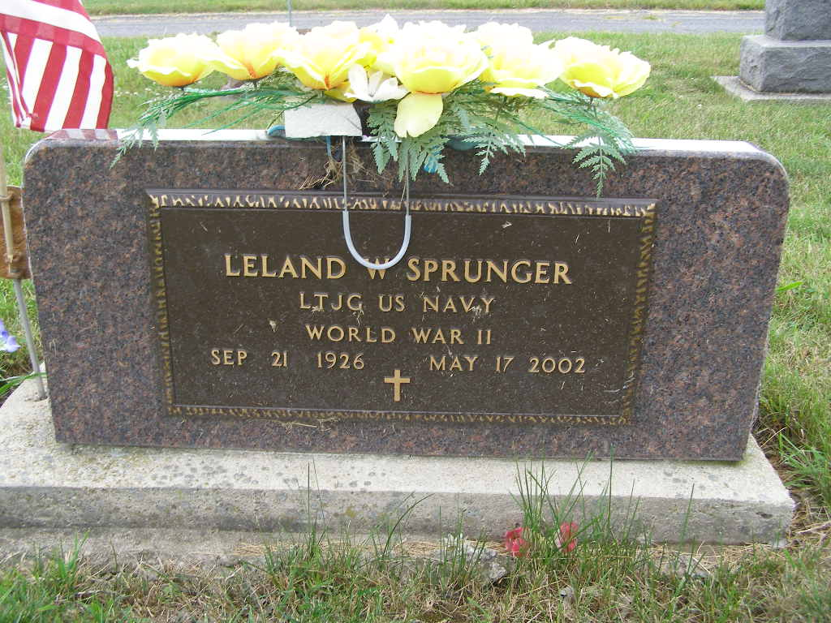

LELAND W. SPRUNGER, 75, died Friday in Warminster, Pa. Born in Adams County, he was an electrical engineer and acoustical research scientist with the U.S. government. Surviving are wife, Betty Jean of Warminster, Pa.; two sons, Arthur of Geigertown, Pa. and Timothy of Kissimmee, Fla.; two daughters, Elaine Raisner of Warminster, Pa. and Victoria Butchar of Kissimmee, Fla.; two brothers, Paul J. Sprunger and Loren Sprunger, both of Berne; two sisters, Evelyn Hart and Janice Hoffman, both of Berne; and four grandchildren. Services at 11 a.m. Saturday at Yager-Kirchhofer Funeral Home, Berne. Calling from 9 a.m. to 11 a.m. Saturday at the funeral home. Burial in M.R.E. Cemetery, Berne. Memorials to New Hope and Freedom Ministries, P.O. Box 194 Geigertown, PA 19523.

Journal Gazette, The (Allen County, Indiana)
Wednesday, May 22, 2002
**

Indiana, U.S., Birth Certificates, 1907-1944

Name William Leeland Sprunger
Gender Male
Birth Date 21 Sep 1926
Birth Place Berne, Adams, Indiana, USA
Father Menno Sprunger
Mother Mae Stauffer
Certificate Number 43642
Roll number 40474_357802
Volume Range 86 - 90

