Lea Sprunger
September 11, 1864 – February 22, 1906

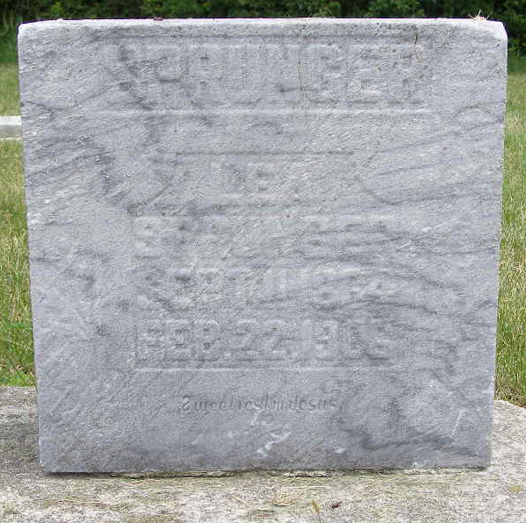
Photo by Shaunda Bedwell Opdycke

Leah Sprunger from tree Julie Frederick Family Tree

Birth 11 Sep 1864 Berne, Adams, Indiana, USA
Residence 1900 Adams, Indiana, USA
Death 22 Feb 1906 Allen, Indiana, USA
Father Jacob Sprunger (1832-1903)
Mother Anna J Sprunger (1843-1918)
14198 People 2 Records 33 Sources
**

U.S., Family History Books

Name Leah Sprunger
Father Jacob Sprunger
Mother Anna Sprunger
Title The Sprunger Family, Descendants of Peter Sprunger, Born 1757, Including His Male Ancestral Line to Hans Sprunger, Born 1565-1575
Author Herr, Willis Eldon, p. 85
3.11 Jacob Sprunger 10-18-1832 - 1903
Jacob was born in Munsterberg, Switzerland and came to America in 1853. He was married on Sept. 26, 1863 to Anna Sprunger ((see 4.3.2.) daughter of Peter E. They lived with his family near Berne, Ind. as farmers.
3.11.1 Leah Sprunger 9-11-1864 - 2-0-1906
She never married.

