Lance David Sprunger
June 8, 1954 – June 8, 1954

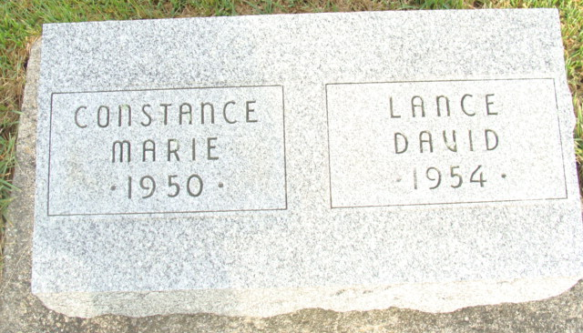
Photo by Alicia Kneuss

Lance David Sprunger from tree 6eggroll.GED
Birth 8 Jun 1954
Death 8 Jun 1954
Father Melvin Edward Sprunger (1920-2002)
Mother Ethelyn Maxine Burnett (1922-2001)
106540 People 0 Records 0 Sources

