LaVera K. Sprunger
August 15, 1922 – February 18, 1999

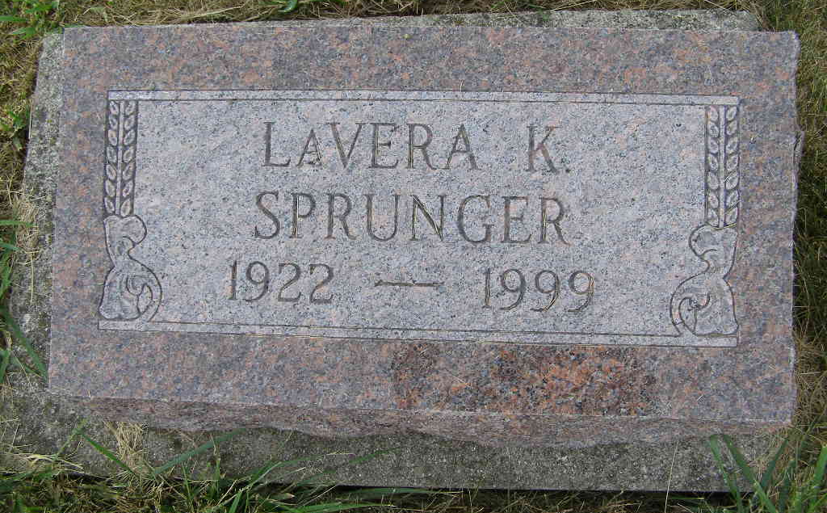
Photo by Shaunda Bedwell Opdycke

LaVera K. Sprunger, 76, of Berne, whose hobbies included crafts and quilting, died Thursday, Feb. 18, 1999, at Swiss Village. The Wells County native had worked for Kroger, Lee's Department Store and E.P. Graphics Company. She taught Sunday school for 39 years and was a member of First Mennonite Church. Surviving are brothers Kenneth E. and Merlin W. Sprunger, both of Berne; and a sister, Deloris Sprunger of Monroe. She was preceded in death by a brother, Arley. Services are 10:30 a.m. Saturday at First Mennonite Church Chapel, Berne, with calling one hour before services. Calling is also from 2 to 8 p.m. today at Yager-Kirchhofer Funeral Home, Berne. Burial will be in M.R.E. Cemetery, Berne. Memorials are to the church's missions or Swiss Village. Information provided by Yager-Kirchhofer Funeral Home, Berne, 1-219-589-3101.

News-Sentinel, The (Allen County, Indiana)
Friday, February 19, 1999
**

Indiana, U.S., Death Certificates, 1899-2017

Name Lavera K. Sprunger
Gender Female
Race White
Marital Status Never
Age 76
Birth Date 15 Aug 1922
Birth Place Wells County
Death Date 18 Feb 1999
Death Place Berne, Adams, Indiana, USA
Death Registration Date 1999
Father Joel N. Sprunger
Mother Clara Ellenberger
Informant Merlin W. Sprunger, brother
Burial 2/20/1999 M.R.E.

