Kent V. Sprunger
February 23, 1930 – June 10, 2019

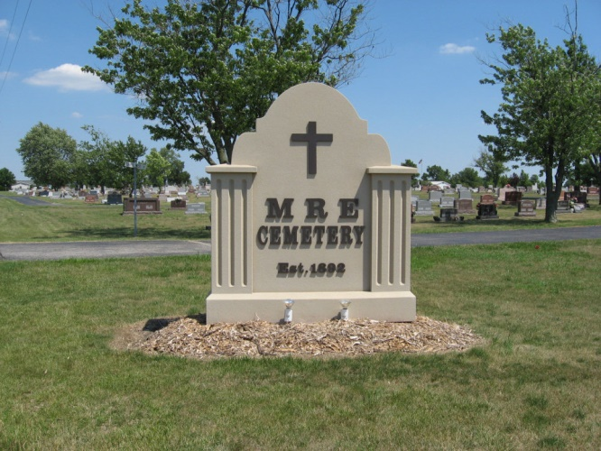
Photo by Tombstoner & Family

Kent V. Sprunger, 89, lifelong resident and building contractor of Berne, passed away on June 10, 2019 at Swiss Village. He was born on February 23, 1930, to Ziggy (Wesley) and Florence (Grime) Sprunger, the youngest of six children. He married Lillian Joyce Baumgartner on April 4, 1955. She survives him at Swiss Village.
Kent loved his hometown, his family, his church, and his work. He counted himself fortunate to have work that was his passion and strove to continue the strong tradition of Swiss carpentry, woodworking, and construction. As a young man just returned from US Army service in Germany, he built his first house in 1953 just north of his home place on Sprunger Street. That house was followed by hundreds of residential and commercial projects over the years. He was the general contractor for half of the main Swiss Village complex.
He was trusted and respected as a high quality and honest builder and enjoyed the confidence and business of countless customers over many decades of hard work. He had the great pleasure of working and laughing with many fine craftsmen on his crew over the years. At age 70 he started yet another business venture, Swiss Lock Box Storage, on Parr Road in Berne. His wife, Lillian, was his support through all his business projects.
KV, as he was known, loved to laugh and lived to talk. He was quick to tell (and re-tell) one of his many stories or repeat one of his many sayings or quips. "There's always room for ice cream; it just fills in the cracks," he would often say. He was a true child of Berne, fondly recounting personal historical facts and stories of yesteryears. He loved horseback riding, beginning with his first horse, Maudine, which he purchased for $150 when he was a young teenager and used to deliver Journal Gazette papers. He loved his dogs throughout the years, and his last dog, Jackie-Ru was often seen riding shot-gun in his truck around town. He also enjoyed playing Euchre with friends and family, who always knew they would hear him sing his rendition of “Jack of Diamonds” at least once during the game.
Kent was a faithful member of the First Mennonite Church in Berne, where he served as Trustee, greeter, and committee member on many, many projects. He also volunteered his time and expertise at Camp Friedenswald in Michigan. He was forever generous with advice, time, and materials to all who asked (and didn't ask). He was a dear husband, father, and friend to many.
He is survived by his wife of 64 years; his children, Gaye (Kent A.) Yoder of Middlebury, and his sons Kent V of the Philadelphia area and Phil (Margaret) of Baton Rouge, LA; six grandchildren, Erin, Allison, Conrad, Carsten, Ian, and Jared; and two great grandchildren, Logan and Dylan. He will be warmly remembered by many in-laws, nieces, and nephews. He was preceded in death by his parents; his sisters, Louise Howell and Patricia Magee; and his brothers Avery, Richard, and Thomas.
Visitation will be at the Zwick & Jahn Funeral Home, Yager-Kirchhofer Chapel in Berne (365 W. Main St, Berne) on Thursday, June 13, from 4:00 to 8:00 p.m. A celebration of his life with family and friends will take place at the First Mennonite Church, Berne, on Friday, June 14, at 10:30 a.m., with visitation one hour prior to the service. Private burial will follow at the MRE Cemetery in Berne.
Memorials may be made to First Mennonite Church of Berne or Camp Friendenswald.

Zwick & Jahn Funeral Home, Adams County, Indiana
Monday, June 10, 2019

