Kenneth Earl Sprunger
August 29, 1920 - August 27, 2017

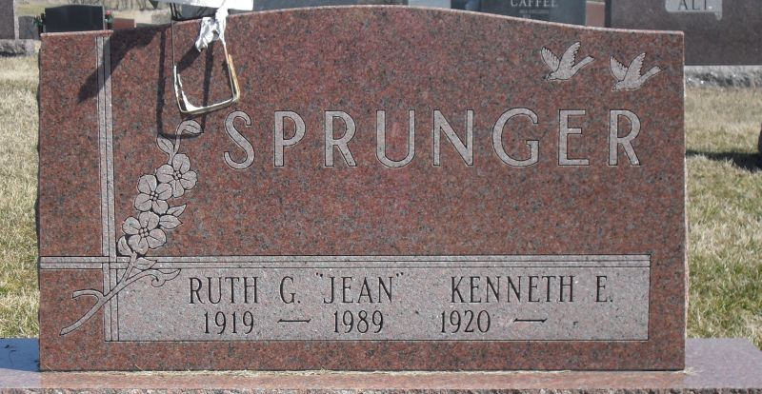
Photo by Stephen & Andrea Brangan

Kenneth Earl Sprunger, 96, Berne, passed away on Sunday evening, August 27,2017 just two days before his 97th birthday at Swiss Village where he was a resident. He was born to Joel and Clara Ellenberger Sprunger in Monroe Township, IN on August 29, 1920.
Drafted into the Army in August of 1942, he was an observer and spotter at Dutch Harbor, Unalaska. His service also took him to the Aleutian Islands of Adak and Great Sitkin and was eventually discharged in January 4, 1946. Kenneth began taking flying lessons at Brigham Field in Portland, IN and received his pilot's license in January 1948.
He started a lifelong carpentry career at his Uncle Leo Sprunger's construction company managing their cabinet shop, later moving to W.E. Reusser Lumber Company as a finish carpenter. After retiring from Reusser's he worked on his own until 2004. He was a master craftsman who could build just about anything out of wood. He was also known for his love of flowers, especially roses, and in his later years his cactus whose flowers everyone admired.
Kenneth had a love for traveling and has been in every state in the U.S. along with Canada, Mexico, Australia and New Zealand. For a time he delivered motor homes for Fleetwood as far away as California. In November of 2010 he took the Honor Flight to Washington, D.C. with several area men who served in WWII.
Kenneth married Ruth Genevieve (Jean) Strickler Augsberger January 31, 1953 and honeymooned in Florida and Havana, Cuba.
Survivors include a daughter, CeAnn (Tex) Weaver, Berne, daughter-in-law Barbara (Alan) Augsburger, Leo, grandsons; Dean Augsburger, Leo-Cedarville and Brendan Weaver, Berne and two great-grandchild-ren, and a sister, Deloris (Virgil) Sprunger of Swiss Village.
Preceding in death are his parents, wife, Ruth Genevieve (Jean) Sprunger, step-son Alan (Bab) Augsburger, brothers, Merlin W.(Berniece) Sprunger, sister, Lavera Sprunger, infant brother and sister, and wife, Mary Spielman Sprunger.
Funeral services Thursday, 31 at Swiss Village Auditorium at 10:30 am with visitation 1 hour prior. Visitation also Wednesday, August 31 from 2 to 8 pm a Swiss Village. Officiating is Pastor Mike Wertenberger with burial at the MRE Cemetery, Berne.
Preferred memorials to Trinity United Methodist Church &/or Gideon's International.

Yager-Kirchhofer Funeral Home, Adams County, Indiana
August 29, 2017

