Katherine (Neuenschwander) Sprunger
July 28, 1892 – December 8, 1964

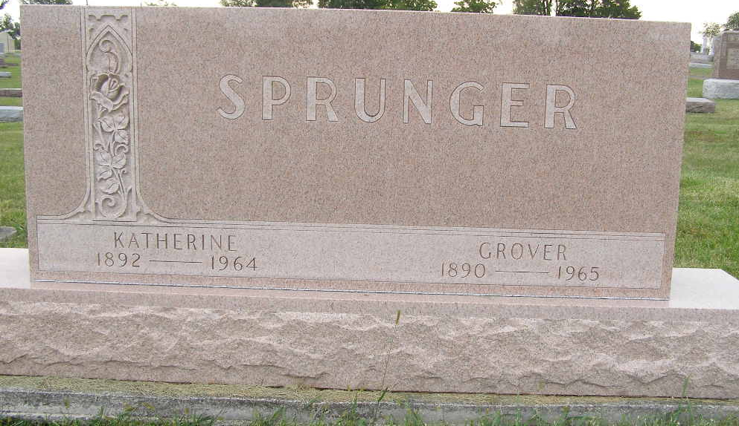
Photo by Shaunda Bedwell Opdycke

Indiana, U.S., Marriage Certificates, 1960-2012

Name Katherine Neuenschwander
Gender Female
Race White
Marriage Age 24
Birth Date 28 Jul 1892
Birth Place Berne, Indiana
Marriage License Date 15 Jun 1917
Marriage Date 17 Jun 1917
Marriage Place Adams, Indiana, USA
Residence Place Berne, Indiana
Spouse Grover Sprunger
**

Catherine Neuenschwander from tree Alvin Family Tree

Birth 28 Jul 1892 Allen, Indiana, USA
Marriage 17 Jun 1917 Allen, Indiana, USA
Residence 1955 Decatur, Adams, Indiana, USA
Death 8 Dec 1964 Miami, Indiana, USA
Father Daniel Neuenschwander (1848-1938)
Mother Catherine Schug (1854-1926)
Spouse Grover William Sprunger (1890-1965)
4691 People 17 Records 21 Sources

