Katherina (Stauffer) Sprunger
May 26, 1861 – May 20, 1932

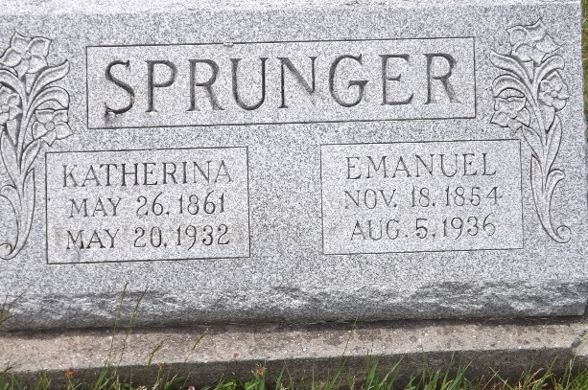
Photo by Jim Allen

KATHERINE SPRUNGER IS TAKEN BY DEATH
Sister of Mrs. Joel Fry Passes Away Friday at Berne
Mrs. Katherine Sprunger, 70, wife of Emanuel Sprunger, died at her home in Berne at 2:50 o'clock Friday morning of paralysis. Mrs. Sprunger suffered a stroke of paralysis last Monday and her condition had been regarded as critical since that time.
She was born in Adams county, May 26, 1861, a daughter of Christian and Verena Habegger-Stauffer. She was united in marriage to Emanuel Sprunger in early life and spent many years on a farm in Monroe township, moving to Berne 8 years ago.
Surviving is the husband and the following children: Mrs. Caleb Sprunger, Rufus, Adolph, Sylvan, and Arley all of Berne, Zilla, at home; four sisters, Mrs. C. A. Neuenschwadner, Mrs. C. C. Neuenschwander, and Mrs. John Lehman, all of Berne and Mrs. Joel Fry of Bluffton; one half brother, Peter Burkhalter of Berne. One sister, Mrs. Jacob Neuenschwander, preceded her in death.
(Cut off)

Evening News Banner, Wells County, Indiana
Saturday, May 21, 1932

