Katherine (Sprunger) Sprunger
November 3, 1853 – November 8, 1938

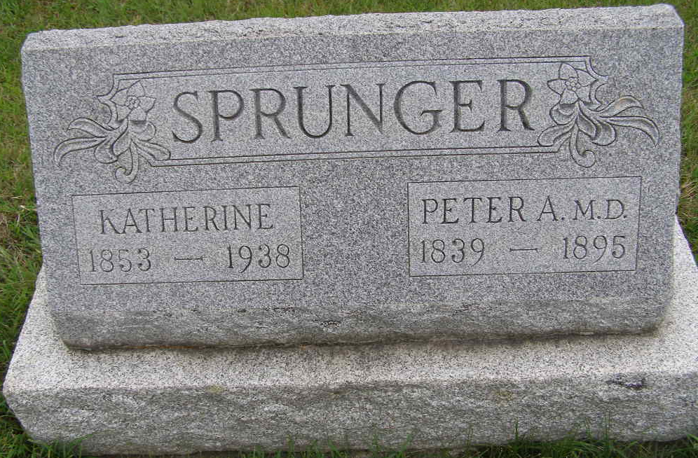
Photo by Shaunda Bedwell Opdycke

DEATH CLAIMS MRS. KATHERINE SPRUNGER HERE
Final Rites Will Be Held at Mennonite Church Thursday P.M.

Mrs. Katherine Sprunger, 85, highly respected widow of the late Dr. Pater A. Sprunger died suddenly Tuesday morning at 7:00 o’clock at her home on Water street. Death was due to angina pectoris. She had been ill only about an hour and a half and death was quite unexpected although she had suffered previous slight attacks.
The deceased spent her entire life in this community, having been born in Monroe township, November 3, 1853, the daughter of Rev. Christian and Marianne Lehman Sprunger. Her husband preceded her in death exactly 43 years ago on the same calendar day, November 8. They were married December 28, 1871 by Mrs. Sprunger’s father.
Mrs. Sprunger sustained a few fractured ribs in a fall this summer but enjoyed fairly good health and participated in a joyful 85th birthday anniversary celebration last week. On Monday she accompanied her grandson, Lowell Sprunger, on a tour through the Berne Manufacturing company which she appreciated and was proof of the fact that she considered her old age a gift and a blessing rather than an infirmity.
Mrs. Sprunger supplied much information for the centennial publication “The First Hundred Years.”
Surviving are the following children: Mrs. Ben Flueckiger of Berne; Reuben of Livingston, Montana; Jerry of Big Fork, Montana; Mrs. David Lehman of Orrville, Ohio; Jonas of Monroe township; Elmer of Dutton, Montana; Abraham of Lima, Ohio; Mrs. Arman Habegger of Monroe township; Mrs. Elmer Luginbill of Berne; Calvin Sprunger, Mildred Sprunger, both of Berne.
Preceding were Anna, Rosina and step-children William J. and Dina.
Also surviving are the following brothers and sisters: Joel Sprunger of Stafford, Kansas; Mrs. Sam Steiner of Berne; Gideon Sprunger and Rosina Sprunger and Mrs. Fred Hanni all of Berne.
Brothers and sisters preceding were Mrs. Chris Gilliom, Mrs. Abe Beer, Mrs. Chris Burry and Ulrich Sprunger.
She was a member of the First Mennonite church of Berne, where funeral services will be held at 2:00 o’clock Thursday afternoon following brief services at the home at 1:30 p.m. Rev. C. H. Suckau will officiate. Burial will be in the M. R. E. cemetery.

Unknown newspaper clipping

