Katharine F. (Luginbill) Sprunger
October 29, 1848 – November 18, 1945

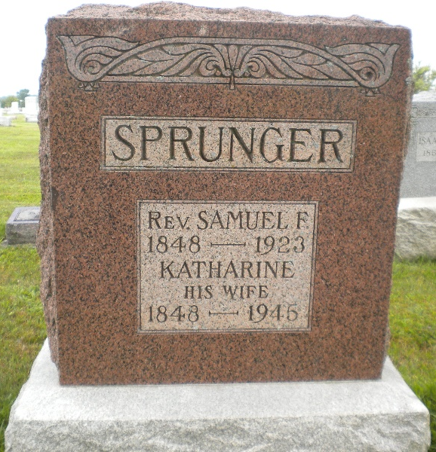
Photo by DSON1492

Indiana, U.S., Death Certificates, 1899-2017

Name Katherin F Luginbill Sprunger
[Katherin F Luginbill Luginbill]
Gender Female
Race White
Marital Status Widowed
Age 96y 11m 21d
Birth Date 29 Nov 1848
Birth Place Adams County, Indiana
Death Date 18 Nov 1945
Death Place Berne, Adams, Indiana, USA
Death Registration Date 1945
Father Peter Luginbill b. France
Mother Barbara Steines
Spouse Rev S F Sprunger
Informant Miss Eva Sprunger, Berne, IN
Burial M.R.E. 11-20-1945

