Katharina (Sprunger) Sprunger
June 22, 1854 – February 2, 1929

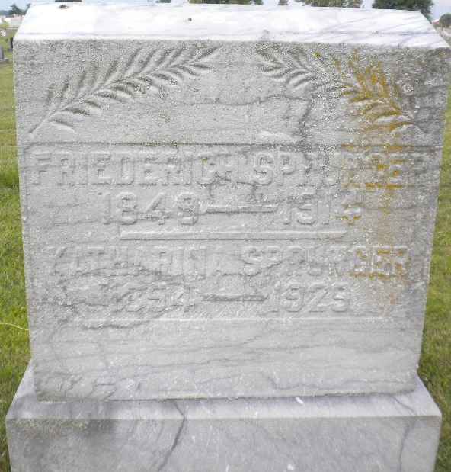
Photo by DSON1492

Indiana, U.S., Death Certificates, 1899-2017

Name Katherine Sprunger
Gender Female
Race White
Marital Status Widow
Age 74y 8m 10d
Birth Date 22 Jun 1854
Birth Place Ohio
Death Date 2 Feb 1929
Death Place Berne, Adams, Indiana, USA
Death Registration Date 1929
Father Abraham J Sprunger b. Switzerland
Mother Katherine Zingg b. Switzeland
Spouse Fredrick Sprunger (deceased)
Informant D. J. Sprunger, Berne, IN
Burial M.R.E. Cemetery 2-4-1929

