Katharina (Nussbaum) Sprunger
November 26, 1863 – October 21, 1918

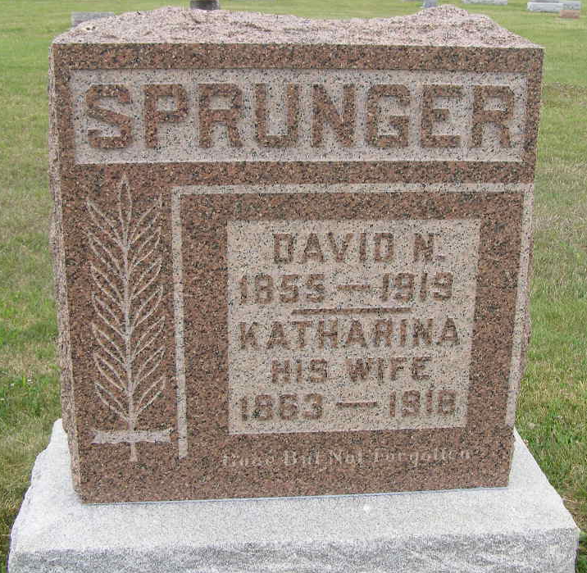
Photo by Shaunda Bedwell Opdycke

Indiana, U.S., Death Certificates, 1899-2017
Name Katharine Sprunger
[Kathrine Nussbaum]
Gender Female
Race White
Marital Status Married
Age 54y 10m 25d
Birth Date 26 Nov 1863
Birth Place Berne, Switzerland
Death Date 21 Oct 1918
Death Place Monroe, Adams, Indiana, USA
Death Registration Date 1918
Father David Nussbaum b. Berne, Switzerland
Mother Kathrine Tschanni b. Switzerland
Spouse David M. Sprunger, informant
Burial M.R.E. Cemetery 10/24/1918

