Katharina (Moser) Sprunger
August 4, 1843 – June 24, 1901

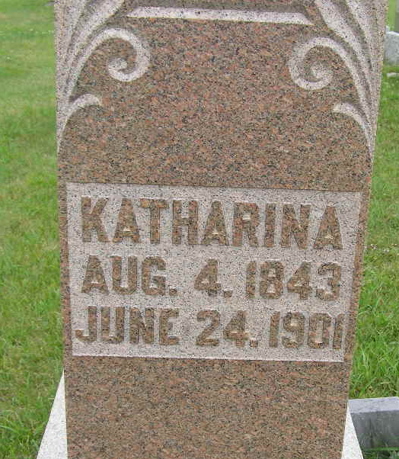
Photo by Shaunda Bedwell Opdycke

Indiana, U.S., Death Certificates, 1899-2017

Name Katharina Sprunger
[Katharina Messia]
Gender Female
Race White
Marital Status Married
Age 57
Birth Date abt 1844
Birth Place Indiana
Death Date 24 Jun 1901
Death Place Berne, Adams, Indiana, USA
Death Registration Date 1901
Father Peter Messia (looks like Mosser) b. Switzerland
Mother Katy Charly (looks like Charlz) b. Switzerland
Informant A Sprunger, Berne, IN
Burial 6/26/1901 M.R.E. Cemetery

