Katharina C. (Sprunger) Sprunger
September 3, 1859 – April 4, 1934

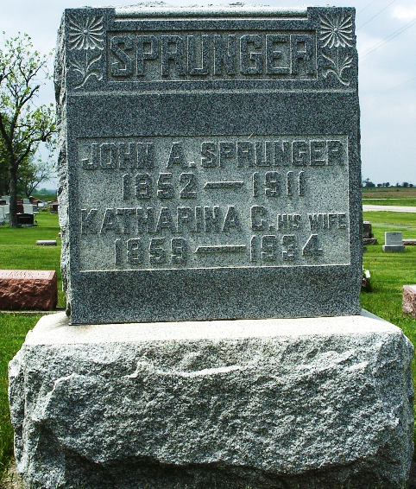
Photo by Max Haines

MRS. SPRUNGER PASSES AWAY TUESDAY NIGHT
Prominent Local Woman is Victim of 5-Months' Illness of Cancer FUNERAL IS FRIDAY P. M.

Early Wednesday morning, at 1:15 o'clock occurred the death of Mrs. J. A. Sprunger, well known local woman. She died at her home on East Water street, after a sickness which had lasted five months. Death was caused by cancer of the oesophagus. She was unable to take proper nourishment because of the cancer and gradually became weaker. Her condition had been critical for several days.
With her husband she was instrumental in founding the Orphans' Home here, and she gave most of her ability, time and energy toward philanthropic work. Mrs. Sprunger was a daughter of Mr. and Mrs. Christian P. Sprunger, who came here from Switzerland. Her birth took place September 23, 1859, on a farm one mile south of Berne, known as the Albert Zuercher farm. The exact age at the time of death was 74 years, six months and 12 days.
She was revered as "mother" to a host of children scattered all over the country and some foreign countries. The orphanage here began with two children and grew rapidly and at one time contained nearly one hundred orphans. Mr. and Mrs. Sprunger, following the death of Hillegonda, pledged themselves to a sacrificial life and made a trip to Switzerland to acquaint themselves with this kind of work. They returned to Berne and formerly opened a deaconess home here on February 1, 1892. Miss Mary Gerber, who came here from Switzerland as a trained nurse and deaconess served as matron. The first candidates for deaconess here were Kate Moser and Leah Sommer, Pandora, Ohio, Mathilda Kohm, New York City, Lena Berberat and Fannie Geiser, Switzerland; Anna and Fanny Scheidegger, Emma and Adina Reusser, of this place. After four months' training they were ordained and the institution was fully established. It was named, and known widely as the "Light and Hope Deaconess and Orphans' Home".
(Missing) home was opened (missing) the first two children were Leo Graham and a Jewish baby girl named Josephine who had no family name. They were brought here from Chicago by Mrs. Sprunger and Fred Rohrer, the latter having joined Rev. Sprunger in (missing) ...for many years and proved to be a blessing. Other branches were established in Evansville, Detroit and Cleveland. By this time, the number of orphans in Berne had grown to over seventy and the quarters became too small. The work and children were transferred to Birmingham, O. in November 1903. On April 19, 1899, the orphan's home building known as Jerusalem was destroyed by fire and three of the orphans perished: Katie Goebelberger, 15, Mamie Broderick, 14 and Maggie Dell, 9. In 1896 at Cleveland they sustained another serious fire and another life was lost, Miss Minnie Blumer, one of the deaconesses. In all they sustained serious losses in five fires in two of which some lives were lost. Three of the fires were in Berne, one in Cleveland and one in Birmingham.
Her marriage to Rev. John A. Sprunger took place Feb. 15, 1880. He preceded her, passing away at Birmingham, September 28, 1911. Three children were born to this union, all deceased. They were Hillegonda, Edmund and Salem. Helen Sprunger, an adopted daughter, and Donald Robinson are at home. Brothers and sisters who survive are J. F. Sprunger of Berne and Miss Sara C. Sprunger of Berne. Brothers and sisters who preceded (Cut off)

Adams County (IN0 Historical Society
1934 Scrapbook, image 33
Handwritten: Thursday, April 5, 1934

