Kae Linnet Sprunger
September 11, 1937 - April 11, 2014

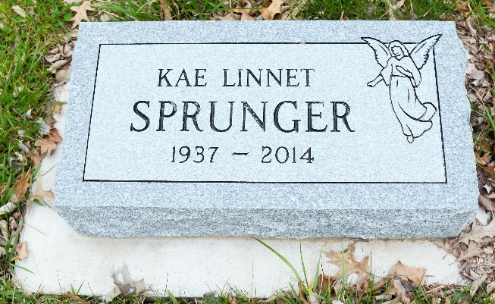
Photo by Deb Curry

Kae Linnet Sprunger, 76, Berne passed away on Friday, April 11, 2014 at Swiss Village. She was born to Vincent and Miriam (Yeoman) Sprunger on September 11, 1937 in Adams County. She was a member of the First Missionary Church and was a missionary nurse to Sierra Leone, West Africa serving 27 years. She later was employed at Swiss Village, Berne.
She graduated from Fort Wayne Bible College, Ball State University, and Indiana University in Indianapolis. Her special interests were crocheting, reading, sports, and singing.
Surviving are Jon Garth Sprunger of Leonidas, Mich., Michael (Carolyn) Sprunger of Linn Grove, Alice Coblentz of Berne, Eric (Jean) Sprunger of Berne, Rebecca Sprunger of New York, and Jared (Jerri Hoffman) Sprunger of Ft. Wayne.
Preceding in death are her parents and brother, Steve Sprunger.
Funeral services are Thursday, April 17, 2014 t 10:30 am at the Swiss Village Chapel with visitation 1 hour prior to services. Visitation also Wednesday, April 16 from 3 to 8 pm in the chapel. Officiating is Pastor Max Haines. Burial is in the M.R.E. Cemetery, Berne.
Preferred memorials are to the Swiss Village Samaritan Fund.

Yager-Kirchhofer Funeral Home, Adams County, Indiana

