Justine (Linn) Sprunger
December 29, 1904 – December 9, 1982

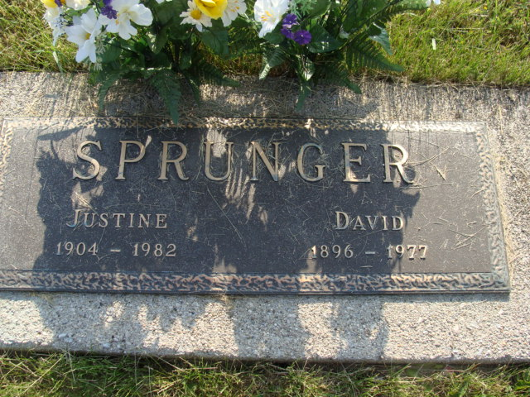
Photo by Alicia Kneuss

Florida, U.S., Death Index, 1877-1998

Name Justine Sprunger
Race White
Age at Death 77
Birth Date 29 Dec 1904
Death Date 9 Dec 1982
Death Place Lake, Florida, United States
**

Justine Linn from tree Anderson Family Tree

Birth 29 Dec 1904 Indiana, USA
Residence 1910 Wells, Indiana, USA
Death 9 Dec 1982 Fort Wayne, Allen, Indiana, USA
Father Oliver T Linn (1870-1949)
Mother Cora Ella Hall (1875-1921)
Spouse David Sprunger (1896-1977)
7616 People 4 Records 5 Sources

