Joshua Sprunger
December 24, 1858 – October 23, 1923

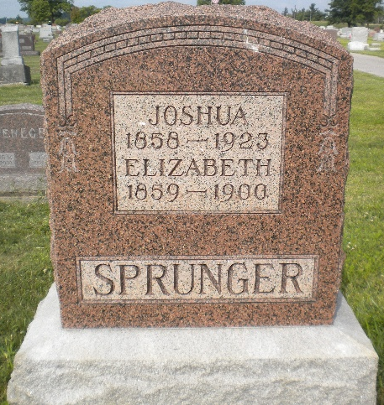
Photo by DSON1492

RETIRED FARMER DIES AT BERNE
Joshua Sprunger Died Suddenly While At Work; Apoplexy Is Cause

Joshua Sprunger, 64, prominent retired farmer, died in Berne Tuesday afternoon. Death was sudden and was due to apoplexy. Mr. Sprunger was at work, carrying bricks and mortar at the Harve Nussbaum home in the northwest part of Berne, for Peter Mazelin, who is doing some mason work on the new home.
No one witnessed the death as it is impossible to determine just in what position Mr. Sprunger was when the attack came upon him. It was reported at first that he was attacked while he was ascending a ladder and fell to the ground. The position of the material and his body as it lay on the ground appears that he had just wheeled a wheel-barrow load of bricks to the foot of a ladder that led to the top of the porch roof. He had already filled a clamp with bricks and was just ready to ascend to the roof when death came upon him. His body evidently fell against the wheel-barrow as it had been spilled when he was found.
His lifeless body was discovered by one of his little grandsons, who happened to be at the new house, evidently very few seconds after Mr. Sprunger had died. The lad at once notified Mr. Mazelin and his mother, Mrs. Otto Stucky, who lives near the Nussbaum house. Help was immediately gotten, but life had faded before the body was found. An ambulance was summoned and the body was taken to the Stucky home where he had been staying.
Mr. Sprunger had apparently been in good health and no one had expected an attack of this nature. He had never complained about his health and was evidently feeling well or he would not have ventured to do such tremendous labor.

Joshua Sprunger was the son of David Sprunger and was born in Wayne County, Ohio, on Dec. 24, 1858. Much of his life was spent in Ohio, until he moved to Berne. On May 15, 1882, he was united in marriage to Miss Elizabeth Habegger who preceded him to the grave 23 years ago, having died on June 21, 1900. Since her death, Mr. Sprunger has remained a widower. To this union were born 11 children, all of whom survive to mourn his sad departure.
Following are the children: Mrs. John Von Gunten, of Fort Wyne; Mrs. Emanuel Neuenschwander, Mrs. Otto Stucky, Mrs. Rufus Von Gunten, of Berne; George, of Fort Wayne; Mrs. Walter Liechty and Andrew, of Berne; Alfred and David of Fort Wayne; Clinton and Mrs. Clifton Gilliom, of Berne. The brothers and sisters are: Isaac of Fort Wayne; Philemon and Amos of Dalton, Ohio; Mrs. Judith Lehman, Mrs. Joel Lehman and Mrs. Amos Burkhalter of Berne; Mrs. C. C. Moser of Fort Wayne. Half-brothers and half-sisters are: Caleb and Martin L. Sprunger of Berne; Mrs. E. Baumgartner and Mrs. David Sommer of Fort Wayne; Mrs. Frank Amstutz, Mrs. Wilbur Nussbaum of Berne and Mrs. Adolph Sprunger of Monroe. Twenty-six grandchildren also survive.
The funeral services will be held Friday morning at 8:30 o'clock from the Otto Stucky home and at 9:00 o'clock from the Mennonite Church.

Decatur Daily Democrat, Adams County, Indiana
Thursday, October 25, 1923
**

Indiana, U.S., Death Certificates, 1899-2017

Name Joshua Sprunger
Gender Male
Race White
Marital Status Widower
Age 64
Birth Date 24 Dec 1858
Birth Place Adams County, Indiana
Death Date 23 Oct 1923
Death Place Berne, Adams, Indiana, USA
Death Registration Date 1923
Father David Sprunger
Mother Barbara Lehman
Spouse Elizabeth
Informant Mrs. Otto Stucky; Berne, Indiana
Burial October 26, 1923; MRE Cemetery

