Jonathan David Sprunger
February 18, 1957 – March 22, 1977
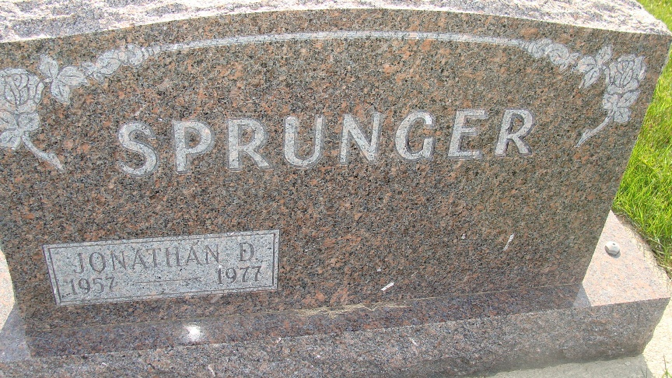
Photo by Alicia Kneuss

A Berne young man who was to be married on April 2 lost his life in a car-truck crash on U.S. Highway north of Bryant, in Jay County at 11 a.m. Tuesday. Dead at the scene was Jonathon Sprunger, 20, son of Mr. and Mrs. Sprunger of 405 Clare Street, engaged to marry Sandra All??? of Bryant. Sprunger died when his car had slid into the path of a Berne truck and trailer loaded with groceries for Gifford’s IGA Store. The truck was driven by Charles N. Ledley, of Liberty, Ohio.
Sprunger was born in Jay County, a son of Logan and Anita Kennel Sprunger. He had been employed at CTS of Berne, Indiana for seven months.. He was a member of the First Mennonite Church, and was a graduate of South Adams High School, class of 1975.
Surviving are the parents; a brother, Scott C. Sprunger, Monroe; two sisters, Mrs. Floyd (Renee) Liechty, Berne and Jilaine, at home; maternal grandparents, Mr. and Mrs. Alvin Kennel, and the paternal grandmother, ??? Clarence Sprunger, all of Berne.
The body is at the Yager Funeral Home where friends may call at ??? a.m. Thursday. Services will be held at 10 a.m. Friday in the Chapel of the First Mennonite Church, Rev. Curt A. ??? officiating. Burial will be in the MRE Cemetery. The body will lie in state at the church Friday from 9 a.m. until the time of service.
Burial Plot: S27-28-4-3
Date of Death: March 22, 1977; Date of Burial: March 24, 1977

Berne (IN) Library Heritage Room
1973-1984 MRE Obit Book, image #146
**
Indiana, U.S., Death Certificates, 1899-2011
Name: Jonathan David Sprunger
Gender: Male
Race: White
Age: 20
Marital status: Never Married (Single)
Birth Date: 18 Feb 1957
Birth Place: USA
Death Date: 22 Mar 1977
Death Place: North of Bryant, North of Bryant Ind, Indiana, USA
Father: Logan Sprunger
Mother: Anita Kennel
Informant: Logan Sprunger; father; Berne, Indiana
Burial: March 25, 1977; MRE Cemetery

