Jonas Sprunger
October 13, 1882 – September 6, 1977
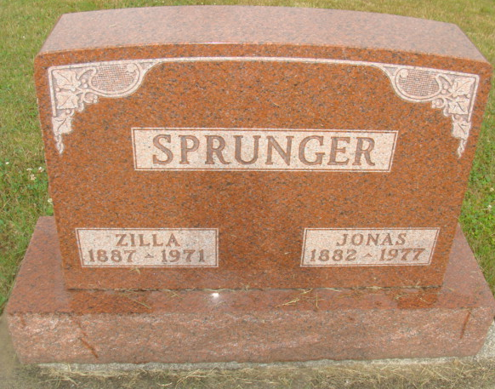
Photo by Alicia Kneuss

Indiana, U.S., Death Certificates, 1899-2017
Name Jonas Sprunger
Gender Male
Race White
Marital Status Widowed
Age 94
Birth Date 13 Oct 1882
Birth Place Indiana
Death Date 6 Sep 1977
Death Place Decatur, Adams, Indiana, USA
Death Registration Date 1977
Father Peter A Sprunger
Mother Catherine Sprunger
Informant Merlin Sprunger; son; Berne, Indiana
Burial September 9, 1977; MRE Cemetery; Berne, Indiana

